
Integrated Business Operations Platform (IBOP)
Submitted In Partial Fulfillment of Requirements
For the Degree Of
Bachelor of Technology
(Computer Engineering)
By
Mann Dutiya
Roll No: 16010123192

Guide
Dr. Anushree Deshmukh

Somaiya Vidyavihar University
Vidyavihar, Mumabi - 400 077
2023-27






Abstract
The Integrated Business Operations Platform (IBOP) is a centralized web-based business management system developed to streamline and integrate multiple operational workflows within an organization. The project was undertaken in collaboration with Shrinath Enterprises, a surgical and pharmaceutical distribution agency, with the objective of improving operational efficiency, data visibility, inventory management, and inter-departmental coordination.
Many small and medium-sized enterprises rely on disconnected systems for handling sales, inventory, finance, employee management, and operational tracking. This often results in data inconsistency, manual overhead, delayed decision-making, and inefficient workflow coordination. IBOP addresses these challenges by providing a unified platform capable of managing sales operations, inventory tracking, purchase management, invoice generation, expense tracking, and employee management through role-based access control.
The system is developed using the MERN stack consisting of React.js, Node.js, Express.js, and MongoDB. JWT-based authentication and role-based authorization mechanisms are implemented to ensure secure access to different modules. The platform also provides automation features such as automatic stock synchronization, GST calculation, invoice generation, and purchase-expense integration.
The proposed system improves workflow efficiency by centralizing operational activities into a single platform while providing real-time business insights through dashboards and analytics. The project demonstrates the practical implementation of full-stack development, business workflow automation, database integration, authentication systems, and enterprise application architecture.

Contents
Chapter 1 9
Introduction 9
1.1 Background 9
1.2 Problem Statement 10
1.3 Motivation 11
1.4 Objectives 12
1.5 Scope of the Project 13
1.6 Methodology 13
1.7 Organization of Report 14
Chapter 2 15
Literature Survey 15
2.1 Existing Business Management Systems 15
2.2 Inventory Management Systems 16
2.3 Authentication and RBAC Systems 17
2.4 MERN Stack Enterprise Applications 18
2.5 Comparative Analysis 20
2.6 Research Gap 22
Chapter 3 23
System Design and Architecture 23
3.1 System Architecture 23
3.2 Technology Stack 26
3.3 Database Design 28
3.4 Module Design 32
3.5 Authentication and Security Mechanisms 35
3.6 Workflow Design and Data Flow 38
3.7 Advantages of Proposed System 40
Chapter 4 42
Implementation and Experimental Results 42
4.1 Frontend Implementation 42
4.2 Backend Implementation 53
4.3 Inventory and Sales Workflow 61
4.4 Invoice and Financial Management 63
4.5 Role-Based Access Implementation 65
4.6 Testing and Validation 68
4.7 Results and Discussion 72
Chapter 5 75
Conclusions and Further Scope 75
5.1 Conclusion 75
5.2 Future Scope 76
REFERENCES 80

List of Figures
Figure 3.1 System Architecture Diagram ............................... 26

Figure 3.2 Entity Relationship Diagram ............................... 31

Figure 3.3 Use Case Diagram .......................................... 35

Figure 3.4 Authentication Workflow Diagram ........................... 38

Figure 3.5 Operational Workflow Diagram .............................. 40

Figure 4.1 Dashboard Interface ....................................... 45

Figure 4.2 Product Management Interface .............................. 47

Figure 4.3 Product Listing Interface ................................. 48

Figure 4.4 Sales Records Interface ................................... 49

Figure 4.5 Sales Creation Interface .................................. 50

Figure 4.6 Invoice Management Interface .............................. 51

Figure 4.7 Generated Invoice Document ................................ 52

Figure 4.8 Financial Analytics Dashboard ............................. 53

Figure 4.9 Expense Management Interface .............................. 54

Figure 4.10 Employee Registration Interface .......................... 57

Figure 4.11 Employee Records Interface ............................... 58

Figure 4.12 Backend Project Structure ................................ 61

Figure 4.13 Authentication Middleware Workflow ....................... 65

Figure 4.14 Backend API Workflow ..................................... 67

Figure 4.15 Product Addition Interface ............................... 70

Figure 4.16 Product Inventory Listing ................................ 70

Figure 4.17 Sales Transaction Interface .............................. 71

Figure 4.18 Sales Records Management ................................. 71

Figure 4.19 Inventory and Sales Workflow Diagram ..................... 72

Figure 4.20 Invoice and Financial Workflow Diagram ................... 74

Figure 4.21 Role-Based Authentication Workflow ....................... 76

List of Tables

Table 2.1 Comparative Analysis of Existing Systems .................. 21

Table 3.1 Technology Stack Summary ................................. 30

Table 4.1 System Testing Summary ................................... 74

Table A.1 Authentication API Endpoints ............................. 77

Table A.2 Product API Endpoints .................................... 77

Table A.3 Sales API Endpoints ...................................... 78

Table A.4 Purchase API Endpoints ................................... 78

Table A.5 Invoice API Endpoints .................................... 78

Table A.6 Expense API Endpoints .................................... 79

Table A.7 Employee API Endpoints ................................... 79

Table A.8 Dashboard & Analytics API Endpoints ...................... 79
APPENDIX A 77
API ENDPOINT TABLES 77
APPENDIX B 79
Company Collaboration Letter 79

Chapter 1

Introduction
This chapter introduces the Integrated Business Operations Platform (IBOP), its objectives, motivation, scope, and methodology. It discusses the challenges faced by small and medium-sized enterprises due to fragmented operational systems and explains the need for a centralized business management platform.

1.1 Background
In recent years, digital transformation has become increasingly important for organizations seeking to improve operational efficiency, workflow management, and decision-making capabilities. Small and medium-sized enterprises (SMEs), especially those operating in sectors such as pharmaceutical distribution, retail, and inventory-based businesses, often face challenges in managing their day-to-day operations due to fragmented systems and manual processes. Many organizations continue to rely on spreadsheets, paper-based records, or multiple disconnected software solutions for handling sales, inventory, employee management, invoicing, and financial tracking. This leads to issues such as data inconsistency, duplication of records, delayed reporting, reduced transparency, and inefficient coordination between departments.
With the rapid growth of technology and increasing business complexity, organizations require centralized systems capable of integrating multiple operational activities into a single platform. A unified business management platform enables better coordination between various departments by maintaining consistent data flow and providing real-time visibility into organizational activities. Such systems also reduce manual workload, minimize human errors, improve record management, and support faster decision-making through centralized dashboards and reporting tools.
In pharmaceutical and surgical distribution businesses, operational efficiency is particularly important due to the continuous movement of inventory, order management, billing processes, supplier coordination, and financial tracking. Managing these operations manually or through disconnected systems can create significant challenges in maintaining stock accuracy, generating invoices, tracking expenses, and monitoring employee activities. The absence of centralized monitoring may also affect inventory synchronization and overall business productivity.
The Integrated Business Operations Platform (IBOP) is designed to address these challenges by providing a centralized web-based solution for managing multiple business operations within a single system. The project was undertaken in collaboration with Shrinath Enterprises, a pharmaceutical and surgical distribution agency, with the objective of streamlining operational workflows and improving overall business management efficiency. The platform integrates important business functions such as inventory management, sales management, purchase tracking, invoice generation, employee management, expense monitoring, and dashboard analytics into a unified environment.
The proposed system is developed using the MERN technology stack consisting of MongoDB, Express.js, React.js, and Node.js. The platform uses JWT-based authentication and role-based access control mechanisms to ensure secure access to different modules and functionalities. Automation features such as real-time stock synchronization, GST calculation, and invoice generation are incorporated to reduce manual effort and improve operational accuracy.
IBOP aims to provide organizations with a scalable and efficient operational management solution capable of improving workflow integration, data accessibility, and business transparency. By centralizing operational activities into a single digital platform, the system contributes towards improved coordination, better resource management, and enhanced productivity within business environments.

1.2 Problem Statement
Many small and medium-sized enterprises face operational challenges due to the use of fragmented management systems and manual business processes. Different organizational activities such as inventory management, sales tracking, employee management, expense recording, and invoice generation are often handled using separate tools or manual methods. This creates difficulties in maintaining data consistency, coordinating workflows between departments, and obtaining real-time visibility into business operations.
In pharmaceutical and surgical distribution businesses, operational management becomes more complex because of continuous inventory movement, supplier coordination, billing processes, and financial tracking requirements. Managing these operations through disconnected systems increases the risk of human error, stock inconsistency, delayed reporting, duplicate data entry, and inefficient decision-making. Manual workflows also make it difficult to maintain synchronized records across different operational modules.
During the analysis of workflows at Shrinath Enterprises, several practical operational challenges were identified. Inventory updates were difficult to track efficiently across purchases and sales activities, invoice generation involved repetitive manual processes, and financial records were not fully integrated with operational workflows. The absence of a centralized system also limited the organization’s ability to monitor business activities in real time and reduced overall operational transparency.
Another major challenge was the lack of role-based access control within operational systems. Different employees and departments require access to specific functionalities depending on their responsibilities. Without a structured access management mechanism, maintaining data security and workflow control becomes difficult. Additionally, disconnected systems reduce scalability and make future expansion or integration of business operations more complicated.
The existing workflow limitations highlighted the need for a centralized digital platform capable of integrating multiple business operations into a unified environment. The system needed to support inventory management, sales tracking, purchase handling, invoice generation, expense monitoring, employee management, and real-time dashboard analytics while maintaining secure role-based access.
To address these challenges, the Integrated Business Operations Platform (IBOP) was proposed as a centralized web-based business management system designed to improve workflow integration, operational visibility, and organizational efficiency. The platform aims to automate important operational processes, reduce manual dependency, improve data consistency, and provide a scalable architecture suitable for real-world business environments.

1.3 Motivation
The increasing dependence on digital systems in modern business environments has highlighted the importance of integrated operational management platforms capable of handling multiple workflows efficiently. Many small and medium-sized enterprises continue to face difficulties in coordinating operational activities due to fragmented systems, manual record keeping, and lack of centralized data management. These limitations reduce operational efficiency and create challenges in maintaining accurate and synchronized business information.
During the study of operational workflows at Shrinath Enterprises, it was observed that several business activities such as inventory tracking, sales management, invoice handling, and expense monitoring required better integration and centralized accessibility. The absence of a unified system increased manual effort and made real-time monitoring of business operations difficult. Repetitive data entry, delayed updates, and isolated operational records further affected workflow efficiency and decision-making capabilities.
The motivation behind developing the Integrated Business Operations Platform (IBOP) was to design a centralized and scalable system capable of integrating multiple business functions into a single digital environment. The project aims to simplify operational workflows by automating routine activities, improving data consistency, and enabling better communication between different organizational modules. By integrating inventory management, finance management, employee handling, invoice generation, and analytics into one platform, the system reduces dependency on disconnected processes and improves operational transparency.
Another major motivation for the project was to apply modern full-stack development technologies to solve real-world business challenges. The project provided an opportunity to implement practical concepts related to database management, authentication systems, API development, role-based access control, frontend-backend integration, and workflow automation within an industrial context. The collaboration with a real business organization also allowed the system to be designed around practical operational requirements rather than purely theoretical assumptions.
The proposed platform is intended to improve workflow efficiency, reduce manual overhead, and provide organizations with a secure and centralized operational management solution. Through the implementation of automation features, role-based access mechanisms, and real-time data synchronization, IBOP aims to support better business coordination and enhance overall productivity within organizational environments.

1.4 Objectives
The primary objective of the Integrated Business Operations Platform (IBOP) is to develop a centralized web-based system capable of integrating multiple business operations into a single unified platform. The system is designed to improve operational efficiency, workflow coordination, data accessibility, and organizational transparency within business environments.
The project aims to address challenges associated with fragmented operational systems by providing integrated modules for inventory management, sales tracking, employee management, purchase handling, invoice generation, expense monitoring, and dashboard analytics. The platform is intended to simplify day-to-day business activities while reducing manual dependency and improving workflow synchronization across different operational processes.

Primary Objectives
- To develop a centralized business operations management platform for organizational workflow integration.
- To implement secure authentication and role-based access control mechanisms for controlled system access.
- To integrate inventory management, sales management, purchase tracking, and financial workflows into a unified environment.
- To automate invoice generation and GST calculation processes.
- To enable real-time inventory synchronization during sales and purchase operations.
- To provide dashboard-based business analytics and operational monitoring features.
- To improve operational transparency and reduce manual record management.

Secondary Objectives
- To design a scalable and modular full-stack web application architecture.
- To develop responsive and user-friendly interfaces for operational management.
- To implement secure API communication between frontend and backend systems.
- To maintain centralized storage and management of operational data using MongoDB.
- To simplify employee and workflow management within the organization.
- To provide a structured foundation for future expansion and additional feature integration.
The project also aims to demonstrate the practical implementation of modern web technologies such as React.js, Node.js, Express.js, MongoDB, JWT authentication, and RESTful APIs in solving real-world business workflow challenges. Through industrial collaboration and workflow analysis, the proposed system focuses on delivering a practical, efficient, and scalable operational management solution suitable for small and medium-sized enterprises.

1.5 Scope of the Project
The scope of the Integrated Business Operations Platform (IBOP) focuses on the development of a centralized web-based system for managing and integrating multiple operational workflows within an organization. The platform is designed primarily for small and medium-sized enterprises requiring efficient coordination between departments such as inventory management, sales management, finance handling, employee management, and operational monitoring.
The system provides functionality for maintaining product inventories, recording sales and purchase transactions, generating invoices, monitoring expenses, and managing employee-related information through a unified digital platform. The project also includes dashboard analytics and reporting features that allow users to monitor operational activities and access business-related insights in real time.
IBOP implements role-based access control mechanisms to ensure that different users are granted access only to functionalities relevant to their roles and responsibilities. Secure authentication and protected API communication are incorporated to maintain system security and controlled data accessibility. Automation features such as GST calculation, invoice generation, and inventory synchronization are also included to reduce manual workload and improve operational accuracy.
The project is developed as a web-based application using the MERN stack and is intended for organizational use within business environments similar to pharmaceutical and surgical distribution agencies. The system is designed with scalability and modularity in mind so that additional features and operational modules can be integrated in future development phases.
Although the platform integrates multiple operational workflows, the current implementation is limited to core business management functionalities and does not include advanced enterprise-level features such as large-scale cloud infrastructure management, AI-driven forecasting systems, payment gateway integration, or mobile application support. These features may be considered for future enhancement and expansion of the system.

1.6 Methodology
The development of the Integrated Business Operations Platform (IBOP) followed a structured methodology involving requirement analysis, system design, implementation, testing, and validation. The methodology was focused on understanding real-world operational challenges and designing a practical solution capable of improving workflow integration and business management efficiency.
The first phase involved requirement gathering and workflow analysis through the study of operational activities at Shrinath Enterprises. Existing business processes related to inventory management, sales tracking, invoice handling, employee management, and expense monitoring were analyzed to identify workflow limitations and operational challenges. Based on this analysis, system requirements and module specifications were defined.
The second phase focused on system design and architecture planning. During this stage, database structures, module interactions, frontend-backend communication flow, authentication mechanisms, and API architecture were planned. MongoDB was selected for centralized data storage, while React.js, Node.js, and Express.js were chosen for frontend and backend development due to their scalability and flexibility in modern web application development.
The implementation phase involved the development of frontend interfaces, backend APIs, authentication systems, database models, and workflow automation mechanisms. Separate modules were developed for inventory management, sales handling, purchase tracking, invoice generation, employee management, and dashboard analytics. JWT-based authentication and role-based authorization were implemented to provide secure system access.
After implementation, testing and validation were performed to verify the functionality and reliability of the system. Different workflows, APIs, authentication mechanisms, and operational modules were tested to ensure correct data handling, inventory synchronization, and secure access control. The final system was evaluated based on workflow integration, operational efficiency, and usability within a business environment.
The adopted methodology enabled systematic development of the platform while ensuring that the proposed system aligned with practical business requirements and operational objectives.

1.7 Organization of Report
This report is organized into five chapters describing the design, development, implementation, and analysis of the Integrated Business Operations Platform (IBOP).
Chapter 1 introduces the background, problem statement, motivation, objectives, scope, and methodology associated with the proposed system. It provides an overview of the operational challenges addressed by the project and explains the purpose of developing a centralized business management platform.
Chapter 2 presents the literature survey related to enterprise resource planning systems, inventory management systems, authentication mechanisms, role-based access control, and MERN stack-based business applications. The chapter also discusses the limitations of existing systems and identifies the research gap addressed by the proposed platform.
Chapter 3 describes the system design and architecture of IBOP. It includes details regarding system architecture, database design, technology stack, authentication flow, module organization, and API structure used in the development of the platform.
Chapter 4 discusses the implementation and experimental results of the proposed system. This chapter explains frontend and backend implementation details, inventory and sales workflows, invoice generation mechanisms, testing procedures, and operational results obtained from the system.
Chapter 5 concludes the report by summarizing the outcomes and achievements of the project. The chapter also discusses limitations of the current implementation and presents possible future enhancements and expansion opportunities for the platform.

Chapter 2

Literature Survey
This chapter presents the literature survey conducted for understanding existing enterprise resource planning systems, inventory management systems, authentication mechanisms, and modern web-based business applications. It discusses research papers, existing methodologies, identified limitations, and technological approaches relevant to the development of the Integrated Business Operations Platform (IBOP). The chapter also highlights the research gaps identified from existing systems and explains how the proposed platform addresses these limitations.

2.1 Existing Business Management Systems
Business management systems and Enterprise Resource Planning (ERP) platforms have become essential tools for organizations seeking to improve workflow coordination, operational efficiency, and centralized data management. These systems are designed to integrate multiple business functions such as inventory management, accounting, sales tracking, customer relationship management, employee management, and reporting into a unified platform. Over the years, several ERP architectures, implementation methodologies, and business management frameworks have been proposed and implemented across different industries.
A literature review on ERP implementation methodologies, modules, software, and policy discussed various ERP implementation approaches including SAP ASAP, Oracle OUM, and Odoo methodologies. The study analyzed ERP systems based on implementation strategies, software models, company size, and module integration. The paper provided a broad understanding of ERP implementation processes and highlighted the importance of selecting suitable architectures based on organizational requirements. However, the study mainly focused on theoretical comparisons and lacked practical implementation analysis, usability evaluation, and real-world performance validation.
Another study on ERP Odoo implementation in small retail businesses focused on business process re-engineering and ERP integration using Odoo-based workflows. The research analyzed existing operational workflows and redesigned them into ERP-oriented processes using fit-gap analysis techniques. Modules such as accounting, inventory, purchase management, and point-of-sale systems were integrated into a unified platform. Although the system improved operational organization and stock management, the study lacked advanced analytics, decision-support mechanisms, and security-focused workflow analysis.
Research on ERP systems architecture for modern enterprise environments discussed different architectural models such as service-oriented architecture (SOA), cloud ERP systems, and modular web-based ERP platforms. The study explained how scalable architectures improve flexibility and workflow integration in modern business applications. It also highlighted the role of modular design in enterprise software development. However, the paper did not provide practical implementation validation or optimization strategies for real-world operational systems.
Studies related to small and medium enterprise management applications emphasized the importance of centralized business systems capable of integrating multiple workflows into a single operational environment. These systems focused on improving coordination between sales, inventory, accounting, and management operations while maintaining user-friendly interfaces and scalable architectures. Despite providing integrated operational environments, many existing systems lacked sufficient analytics, secure access management, and workflow customization capabilities.
The reviewed literature demonstrates that existing ERP and business management systems provide significant improvements in workflow integration, data management, and operational automation. However, many systems either focus heavily on theoretical architecture design or lack practical implementation features such as real-time synchronization, simplified usability, modular customization, secure role-based access control, and centralized analytics. These limitations create opportunities for developing more flexible and practical business operation platforms tailored for small and medium-sized enterprises.
The Integrated Business Operations Platform (IBOP) builds upon the concepts discussed in the reviewed literature by integrating inventory management, sales workflows, employee handling, invoice generation, financial tracking, and dashboard analytics into a centralized web-based system. The platform emphasizes modularity, workflow synchronization, usability, and real-world applicability while maintaining scalability and secure operational access.

2.2 Inventory Management Systems
Inventory management systems play an important role in organizations that handle continuous stock movement, product distribution, warehouse management, and supply chain operations. Efficient inventory management helps businesses maintain accurate stock records, reduce operational losses, improve order processing, and ensure smooth coordination between procurement and sales activities. In industries such as pharmaceutical and surgical distribution, inventory accuracy becomes especially critical due to product sensitivity, stock availability requirements, and operational dependencies between sales and purchase workflows.
Several research studies have proposed web-based inventory management systems for improving inventory tracking and operational monitoring. A study on the design and implementation of an inventory management system for universities presented a web-based architecture developed using PHP, SQL, and frontend technologies. The system included modules for login management, order processing, product distribution, and reporting functionalities. The proposed architecture followed a structured workflow model and provided separate user and administrative modules for better operational control. However, the system focused mainly on inventory management and lacked integration with broader enterprise functionalities such as finance management, employee coordination, and centralized analytics.
Another study on web-based intelligent inventory management systems introduced distributed inventory architectures integrated with fuzzy logic mechanisms for determining reorder levels and stock management decisions. The system attempted to improve inventory efficiency using intelligent decision-making algorithms and graphical dashboards. Although the approach introduced automation and analytical capabilities, the overall architecture became complex and less suitable for small and medium-sized businesses requiring simpler and more practical operational systems. Additionally, the scalability and usability aspects of the proposed system were not fully validated.
Existing inventory management systems generally focus on stock tracking, order handling, and product management. While these systems improve inventory organization and reduce manual record maintenance, many of them operate as isolated solutions without proper integration with sales management, employee workflows, accounting systems, and centralized operational dashboards. This limitation reduces operational visibility and creates challenges in maintaining synchronized business records across multiple departments.
Modern organizations increasingly require inventory systems capable of real-time synchronization with sales and purchase workflows. Businesses also require systems that can automatically update stock levels, validate product availability, generate operational reports, and provide centralized access to inventory-related information. The absence of integrated workflow automation in many traditional inventory systems creates inefficiencies and increases dependency on manual operational processes.
The Integrated Business Operations Platform (IBOP) addresses these limitations by integrating inventory management directly with sales operations, purchase tracking, invoice generation, and financial workflows. The proposed system supports automatic stock updates, centralized product management, role-based operational access, and real-time workflow synchronization within a unified web-based environment. By integrating inventory operations with broader business processes, the platform improves operational coordination and reduces manual dependency in inventory-related activities.

2.3 Authentication and RBAC Systems
Authentication and Role-Based Access Control (RBAC) systems are essential components of modern enterprise applications and web-based management platforms. These mechanisms help ensure secure access to organizational resources by verifying user identity and restricting system functionalities based on user roles and responsibilities. In business management systems handling sensitive operational data such as inventory records, financial information, employee details, and transactional workflows, secure authentication and controlled access management are necessary for maintaining data integrity and operational security.
Traditional authentication systems primarily focused on username-password verification without implementing structured authorization mechanisms. However, as enterprise applications evolved into multi-user systems with multiple operational modules, the need for more advanced access management architectures increased. Role-Based Access Control emerged as an effective approach for restricting access to specific functionalities based on organizational roles such as administrators, managers, employees, and operational staff.
Several enterprise resource planning systems and business management applications reviewed in the literature incorporate modular access control and user separation mechanisms. Research on inventory management systems and ERP architectures highlighted the importance of separating administrative and operational functionalities to improve workflow control and reduce unauthorized system access. These systems demonstrated that role-based separation improves organizational security while simplifying workflow management for different categories of users.
Studies related to modular enterprise architectures and scalable ERP systems also emphasized the importance of layered system design and controlled module accessibility. Modern ERP architectures increasingly use secure API communication, token-based authentication systems, and modular authorization layers to improve operational security and system scalability. JWT-based authentication mechanisms are commonly adopted in web applications because they provide secure stateless authentication suitable for distributed and scalable systems.
Despite the availability of authentication and access control mechanisms in existing systems, many platforms lack flexible and customizable authorization structures suitable for small and medium-sized enterprises. Some systems provide overly complex security architectures that increase implementation difficulty, while others lack sufficient access restrictions and operational control. Inadequate authorization management can result in unauthorized access to sensitive operational data, workflow manipulation, and reduced accountability within organizational systems.
The Integrated Business Operations Platform (IBOP) incorporates JWT-based authentication and role-based access control mechanisms to ensure secure and structured access to different modules of the platform. The system restricts functionalities based on user roles and responsibilities, allowing controlled access to inventory management, sales operations, financial records, employee management, and dashboard analytics. Protected routes and secure API communication are implemented to maintain system security and prevent unauthorized access to operational data.
By integrating authentication and RBAC mechanisms into a centralized business management environment, IBOP improves operational security, workflow control, and user accountability while maintaining a scalable and modular application architecture suitable for real-world organizational deployment.

2.4 MERN Stack Enterprise Applications
The MERN stack, consisting of MongoDB, Express.js, React.js, and Node.js, has emerged as one of the most widely used technology stacks for developing modern web-based enterprise applications. The stack provides a complete JavaScript-based development environment capable of supporting scalable frontend interfaces, backend services, API communication, and centralized database management. Due to its flexibility, modularity, and strong community support, the MERN stack is increasingly adopted for developing business management systems, ERP platforms, inventory management systems, and enterprise workflow applications.
React.js is commonly used for building dynamic and responsive user interfaces through component-based architecture. The framework enables modular frontend development and simplifies the management of complex user interfaces in enterprise systems. Node.js and Express.js provide efficient backend environments for handling API requests, business logic implementation, authentication mechanisms, and workflow processing. MongoDB, being a NoSQL database, offers flexible schema design and efficient handling of large operational datasets commonly found in business applications.
Several modern ERP and business management systems reviewed in the literature utilize modular and web-based architectures similar to MERN-based systems. Research on ERP architecture for modern enterprise applications emphasized the importance of scalable modular systems, service-oriented architectures, and web-based operational platforms capable of supporting real-time communication and centralized workflow integration. These architectural principles closely align with MERN stack application development methodologies.
Research studies involving modular enterprise architectures also discussed layered system design approaches where frontend interfaces, business logic, and database layers operate independently while maintaining coordinated communication. Such architectures improve maintainability, scalability, and flexibility in enterprise systems. The use of modular feature separation allows organizations to independently manage functionalities such as sales, inventory, accounting, and employee operations within the same application environment.
Many web-based business applications and open-source ERP platforms also emphasize browser-based accessibility, modular customization, and centralized operational management. Open-source ERP systems provide organizations with flexibility in adapting workflows according to business requirements while reducing dependency on rigid proprietary architectures. However, several existing systems either become overly complex for small organizations or lack practical usability and simplified workflow integration.
The MERN stack offers several advantages for enterprise application development including rapid frontend development, reusable components, efficient API integration, centralized state management, scalable backend services, and real-time operational synchronization. The technology stack also supports integration of authentication systems, dashboard analytics, reporting tools, and workflow automation mechanisms required in modern business management platforms.
The Integrated Business Operations Platform (IBOP) is developed using the MERN stack to leverage these advantages in building a scalable and modular operational management system. React.js is used for creating responsive user interfaces and modular dashboards, while Node.js and Express.js manage backend APIs, authentication systems, and workflow processing. MongoDB provides centralized storage for inventory records, employee data, sales transactions, invoices, and operational information. The adoption of the MERN stack enables the platform to maintain flexibility, scalability, and efficient integration between different business modules within a unified web-based environment.

2.5 Comparative Analysis
A comparative analysis of the reviewed literature and existing business management systems was conducted to identify commonly addressed functionalities, architectural approaches, limitations, and research gaps relevant to the development of the Integrated Business Operations Platform (IBOP). The analysis focused on ERP implementation methodologies, inventory management systems, enterprise architectures, authentication systems, and web-based operational management platforms.
Most of the reviewed systems provide solutions for workflow integration, inventory management, and enterprise resource planning. Several studies also discuss modular architectures, cloud-based ERP systems, and browser-based enterprise applications. However, many existing systems are either highly theoretical in nature or limited to specific operational functionalities without providing a complete integrated workflow environment suitable for small and medium-sized enterprises.
The literature review also revealed that several existing systems lack practical implementation validation, real-time synchronization capabilities, centralized analytics, flexible role-based access control, and simplified operational workflows. Some systems introduce advanced architectures or intelligent automation techniques but become overly complex and less practical for medium-scale organizational deployment.
The following table presents a comparative analysis of selected systems and their limitations in relation to the proposed IBOP platform.

Table 2.1: Comparative Analysis of Selected Systems and their limitations
Research Work / System | Key Features | Identified Limitations | IBOP Contribution
ERP Implementation Methodologies Review | ERP implementation methodologies, module comparison, software analysis | No practical implementation or usability analysis | Focus on practical implementation and workflow usability
Odoo ERP Implementation for Retailers | Inventory, accounting, purchase management, ERP workflows | Limited analytics and security mechanisms | Real-time dashboards and role-based operational access
ERP Architecture for Modern Systems | Modular ERP architecture, cloud systems, scalable design | Lack of performance validation and optimization analysis | Practical scalable web-based implementation
Modular Enterprise Architecture Systems | Layered architecture and modular workflows | No integrated real-world business workflow implementation | Integrated operational workflow management
Open-Source ERP Systems | Browser-based accessibility and customization | Limited implementation analysis and operational validation | Real-world deployment-focused architecture
Inventory Management Systems | Inventory tracking and reporting | Limited integration with broader enterprise operations | Inventory integration with sales, finance, and employee workflows
Intelligent Inventory Systems | Automated decision-making and analytics | High complexity and limited scalability validation | Simplified and scalable operational workflow system
SME Business Management Applications | Integrated SME operational management | Limited analytics and advanced access control | Dashboard analytics and secure RBAC implementation

The comparative analysis demonstrates that while existing systems provide valuable approaches toward enterprise workflow integration and operational management, there remains a need for practical, scalable, and user-friendly systems capable of integrating multiple operational workflows into a centralized environment. Many existing platforms either focus heavily on theoretical architecture models or provide isolated operational functionalities without seamless workflow synchronization.
The Integrated Business Operations Platform (IBOP) addresses these limitations by combining inventory management, sales operations, invoice generation, employee management, expense tracking, dashboard analytics, and secure role-based access control into a single modular web-based platform. The system emphasizes practical usability, workflow integration, centralized monitoring, and operational scalability within real-world business environments.

2.6 Research Gap
The literature survey conducted on existing ERP systems, inventory management systems, enterprise architectures, and business workflow platforms revealed several limitations and research gaps associated with current operational management solutions. Although many systems provide enterprise-level workflow integration and modular operational management, several practical challenges still exist, particularly for small and medium-sized enterprises requiring scalable, user-friendly, and cost-effective solutions.
Many reviewed ERP implementation studies primarily focus on theoretical methodologies, architectural comparisons, and workflow models without providing detailed practical implementation analysis or real-world operational validation. While these studies explain different ERP approaches and modular structures, they often lack usability analysis, workflow optimization techniques, and practical deployment considerations suitable for medium-scale organizations.
Several existing inventory management systems focus only on stock handling and reporting functionalities without integrating broader business operations such as sales management, employee handling, financial tracking, and centralized analytics. This separation of operational modules creates fragmented workflows and reduces coordination between different organizational activities. In many cases, real-time synchronization between inventory updates, sales operations, and financial records is either limited or completely absent.
Research involving intelligent inventory systems and advanced enterprise architectures introduces automation and analytical techniques but often results in highly complex systems that may not be practical for small and medium-sized businesses. Some architectures prioritize scalability and technical sophistication while overlooking usability, operational simplicity, and workflow accessibility required in real-world business environments.
Another significant limitation identified in several reviewed systems is the lack of flexible and secure role-based access control mechanisms. Many systems either implement limited authorization structures or provide insufficient operational restrictions for different categories of users. This creates challenges in maintaining workflow security, controlled data access, and operational accountability within organizational systems.
Additionally, several existing business management platforms provide limited dashboard analytics, operational visualization, and centralized monitoring capabilities. Organizations increasingly require systems capable of delivering real-time business insights, workflow tracking, and operational transparency through centralized dashboards and reporting interfaces.
The identified research gaps highlighted the need for a centralized, scalable, and practically implementable business management platform capable of integrating inventory management, sales operations, employee handling, financial workflows, invoice generation, and operational analytics within a unified environment. The system also required secure authentication, role-based access control, workflow synchronization, and user-friendly operational interfaces suitable for real-world deployment.
The Integrated Business Operations Platform (IBOP) is proposed to address these gaps by providing a modular web-based system that combines multiple operational workflows into a centralized platform. The proposed system emphasizes practical usability, workflow automation, operational synchronization, secure access management, and scalable architecture while maintaining simplicity and flexibility for organizational deployment in small and medium-sized business environments.

Chapter 3

System Design and Architecture
This chapter presents the system design and architecture of the Integrated Business Operations Platform (IBOP). It describes the overall architecture, technology stack, database design, authentication mechanisms, module organization, and workflow structure of the proposed system. The chapter also explains the interaction between frontend and backend components, role-based access control implementation, and operational data flow within the platform. Various architectural and UML diagrams are included to illustrate the design and implementation of the system in a structured and technically accurate manner.

3.1 System Architecture
The Integrated Business Operations Platform (IBOP) follows a modular layered architecture designed to support scalability, maintainability, workflow integration, and secure operational management. The system is developed using the MERN technology stack consisting of MongoDB, Express.js, React.js, and Node.js. The architecture separates frontend presentation, backend processing, business logic, authentication mechanisms, and database operations into independent layers to improve system organization and simplify future enhancements.
The proposed architecture enables centralized management of business operations including inventory handling, sales management, purchase tracking, employee management, invoice generation, financial monitoring, and dashboard analytics through a unified web-based platform. The layered structure improves communication between modules while maintaining proper separation of concerns across the application.
The frontend of the system is developed using React.js and provides responsive user interfaces for operational management. The frontend layer handles dashboard rendering, user interaction, routing, data visualization, and communication with backend APIs. Different operational modules such as inventory management, sales handling, finance management, and employee administration are accessible through dedicated frontend interfaces.
The backend architecture is developed using Node.js and Express.js. The backend layer exposes RESTful APIs responsible for handling business operations, request processing, authentication, workflow management, and database communication. Separate route handlers and controllers are implemented for different operational modules to maintain modularity and improve maintainability of the application.
Business logic processing is handled within the controller layer. This layer performs important operations such as inventory validation, stock synchronization, GST calculation, invoice processing, expense management, and workflow coordination between different modules. The controller-based architecture ensures that operational logic remains separated from frontend presentation and database structures.
The system implements JWT-based authentication and role-based access control mechanisms to provide secure access management. Authentication middleware validates user tokens and restricts module accessibility based on organizational roles such as Admin, Sales Employee, HR Employee, Finance Employee, Management, and Inventory Manager. Protected routes ensure that only authorized users can access sensitive operational functionalities.
MongoDB Atlas is used as the centralized cloud database for storing operational records including products, sales transactions, purchases, invoices, employee information, and financial expenses. Mongoose models are used for schema definition and database interaction. The database architecture supports modular data organization and efficient handling of operational workflows.
Additional supporting components such as invoice generation services and analytics modules are integrated into the architecture to improve reporting and operational monitoring capabilities. Invoice generation workflows automatically process sales data to create invoice records and PDF invoices, while analytics modules provide business insights through dashboard visualization and reporting mechanisms.
The overall architecture of the proposed system is illustrated in Figure 3.1.
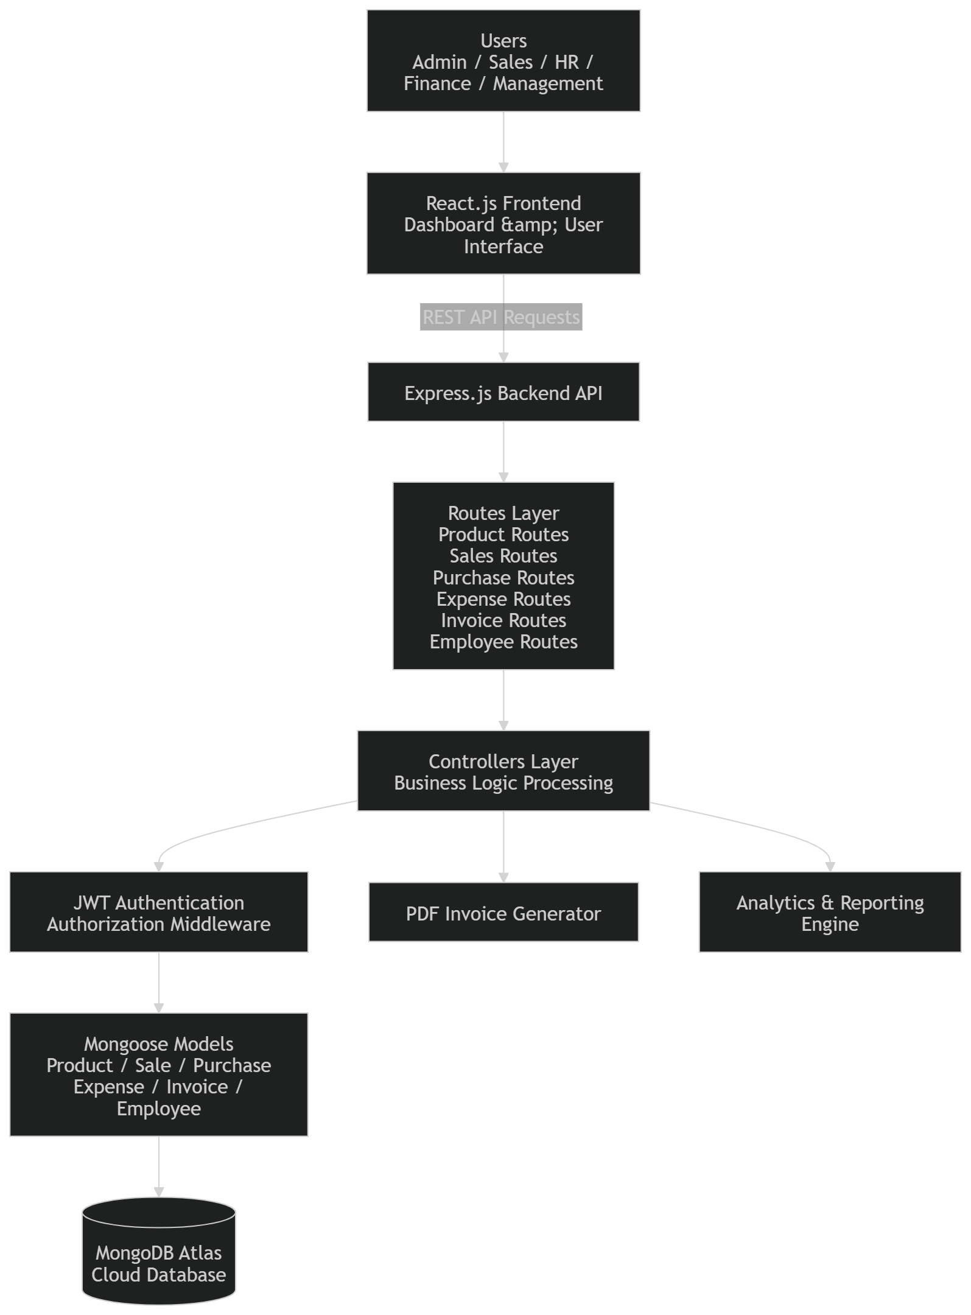
Figure 3.1 System Architecture Diagram
The architecture provides a scalable and organized framework for integrating multiple business operations into a centralized digital platform. By combining modular backend design, secure authentication mechanisms, centralized cloud storage, and responsive frontend interfaces, the proposed system improves workflow coordination, operational transparency, and maintainability within organizational environments.

3.2 Technology Stack
The Integrated Business Operations Platform (IBOP) is developed using modern full-stack web technologies to provide a scalable, modular, and efficient business management solution. The project utilizes the MERN stack, consisting of MongoDB, Express.js, React.js, and Node.js, along with additional libraries and tools for authentication, routing, data visualization, and invoice generation. The selected technology stack supports centralized operational management, secure API communication, responsive user interfaces, and scalable backend processing.

Frontend Technologies
The frontend of the system is developed using React.js, a component-based JavaScript library widely used for building dynamic and responsive web interfaces. React.js enables modular frontend development through reusable components and efficient state management. The frontend architecture supports smooth navigation between operational modules such as inventory management, sales handling, finance management, employee administration, and dashboard analytics.
Tailwind CSS is used for frontend styling and responsive interface design. The utility-first CSS framework simplifies UI development while maintaining consistency across different modules of the application. React Router is used for client-side routing and navigation between pages and protected modules.
The frontend also integrates charting and visualization libraries for dashboard analytics and operational reporting. These components provide graphical representation of financial data, sales statistics, inventory trends, and operational insights within the dashboard interface.

Backend Technologies
The backend of the system is developed using Node.js and Express.js. Node.js provides an asynchronous runtime environment suitable for scalable server-side application development, while Express.js is used for creating RESTful APIs and handling HTTP requests and responses.
The backend architecture follows a modular structure consisting of routes, controllers, middleware, and models. Different operational modules such as products, sales, purchases, expenses, invoices, and employee management are implemented through separate API routes and controller logic. This modular organization improves maintainability and scalability of the system.
Business logic such as stock synchronization, GST calculation, invoice processing, inventory updates, and workflow validation is implemented within the controller layer. Middleware components are used for authentication, authorization, and protected route handling.

Database Technologies
MongoDB Atlas is used as the centralized cloud-based NoSQL database for storing and managing operational data. MongoDB provides flexible schema design and efficient handling of large business datasets required for inventory records, sales transactions, invoices, employee information, and expense tracking.
Mongoose is used as the Object Data Modeling (ODM) library for defining schemas and managing database interaction within the Node.js environment. Schema validation and model relationships are implemented using Mongoose models to maintain organized database structures.

Authentication and Security Technologies
The system uses JSON Web Token (JWT) based authentication for secure user access management. JWT tokens are generated during user login and used for verifying protected API requests. Authentication middleware validates tokens and restricts access to authorized users only.
Role-Based Access Control (RBAC) mechanisms are implemented to provide controlled access to operational modules based on employee roles such as Admin, Sales Employee, HR Employee, Finance Employee, Management, and Inventory Manager.

Additional Technologies and Tools
Additional libraries and utilities are integrated into the system for improving functionality and operational automation. PDF generation libraries are used for invoice generation and downloadable billing reports. Data visualization libraries are integrated for dashboard analytics and reporting functionalities.
Version control and project management are maintained using Git and GitHub for source code organization and collaborative development. MongoDB Atlas provides centralized cloud database management and supports scalable data storage for the application.
Table 3.1 summarizes the technologies used in the development of the proposed system.
Category | Technology Used | Purpose
Frontend | React.js | User Interface Development
Styling | Tailwind CSS | Responsive UI Design
Routing | React Router | Frontend Navigation
Backend | Node.js | Server-Side Runtime Environment
Backend Framework | Express.js | REST API Development
Database | MongoDB Atlas | Cloud Database Management
ODM Library | Mongoose | Schema Modeling and Database Interaction
Authentication | JWT | Secure User Authentication
Authorization | RBAC | Role-Based Access Control
Visualization | Chart Libraries | Dashboard Analytics
Invoice Generation | PDF Libraries | Invoice and Report Generation
Version Control | Git & GitHub | Source Code Management

The selected technology stack provides flexibility, scalability, and modularity required for developing a centralized business operations management platform. The integration of frontend, backend, database, and security technologies enables efficient workflow coordination, secure operational access, and maintainable application architecture suitable for real-world business environments.

3.3 Database Design
The database design of the Integrated Business Operations Platform (IBOP) is structured to support centralized storage and efficient management of operational data related to inventory management, sales transactions, purchases, employee management, invoices, and financial expenses. The system uses MongoDB Atlas as the cloud-based NoSQL database and Mongoose as the Object Data Modeling (ODM) library for schema definition and database interaction.
The database architecture is designed to maintain modular data organization while supporting workflow synchronization between different operational modules. Separate collections are maintained for products, sales, purchases, invoices, employees, and expenses. Relationships between entities are implemented using MongoDB ObjectId references and controller-level operational logic.
The proposed database structure supports scalability, flexible schema management, efficient querying, and centralized operational record handling. Timestamp fields are implemented across most collections to support operational tracking, reporting, and chronological data management.
The primary collections used in the system are described below.

Employee Collection
The employee collection stores authenticated user information and organizational staff records. It is responsible for managing employee details, authentication credentials, and role-based access control information. The collection includes attributes such as employee name, email, password, role, department, salary, contact information, and joining date.
Role information stored within the employee collection is used by the authentication middleware to implement Role-Based Access Control (RBAC) mechanisms across the system.

Product Collection
The product collection acts as the central inventory entity within the system. It stores product-related information including product name, selling price, available stock quantity, batch number, and expiry date. The collection supports inventory synchronization during sales and purchase operations.
The product collection is directly referenced by the sales collection through ObjectId references, enabling accurate stock management and product validation during transaction processing.

Sales Collection
The sales collection stores completed sales transactions and operational sales records. Each sales document contains information such as company name, referenced product ID, quantity sold, rate, discount, total amount, final amount, salesperson details, and transaction date.
The sales module also performs GST calculation and stock synchronization during transaction processing. When a sale is created, the system validates product stock availability and automatically updates inventory quantities.

Purchase Collection
The purchase collection stores supplier purchase records and inventory restocking information. Each purchase entry includes product name, supplier details, purchase quantity, purchase price, GST amount, batch number, expiry date, and final purchase amount.
Unlike the sales collection, purchases do not maintain direct ObjectId references to the product collection. Instead, purchase operations use controller-level logic to match products using product names. If a product already exists, inventory quantities are updated; otherwise, new product records are automatically created within the inventory system.

Invoice Collection
The invoice collection stores invoice records generated from sales transactions. Each invoice document contains a reference to the related sale along with duplicated sales information required for invoice generation and reporting.
The invoice collection includes company details, product information, quantity, pricing details, GST calculations, discount information, payment status, due dates, and financial totals. Invoice data is also used for PDF invoice generation and operational reporting functionalities.

Expense Collection
The expense collection stores organizational expense records and financial expenditure information. Expenses can be recorded manually through the finance module or automatically generated during purchase transactions.
When purchase records are created, the system automatically generates corresponding expense entries within the finance module to maintain synchronization between purchase and financial workflows.
The relationships between different database entities are illustrated in Figure 3.2.
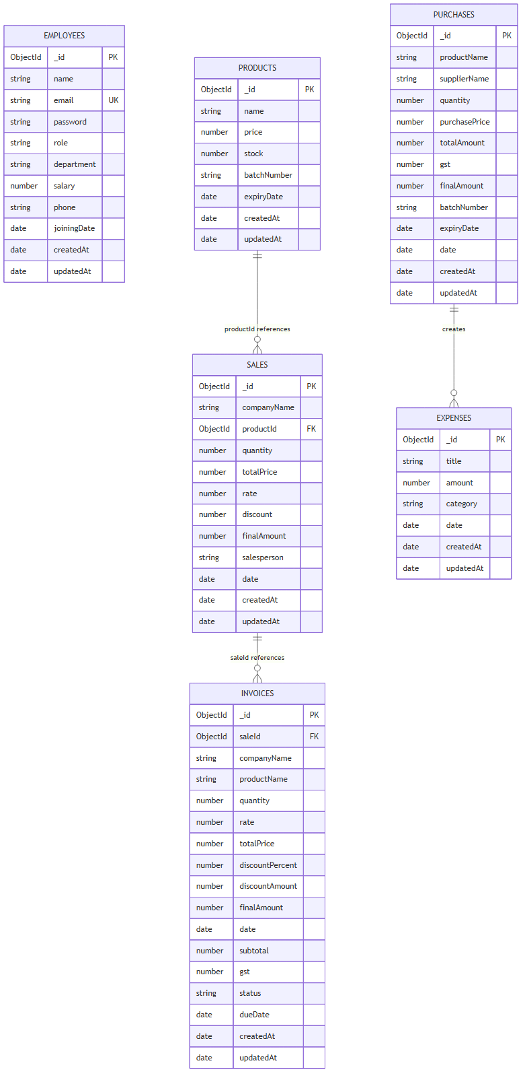
Figure 3.2 Entity Relationship Diagram
The database design follows a partially normalized structure where important transactional relationships are maintained through ObjectId references, while certain operational workflows are handled through controller-level business logic. This design approach simplifies workflow implementation while maintaining flexibility for operational management and reporting.
The use of MongoDB Atlas and Mongoose provides scalable cloud-based storage, schema flexibility, efficient querying capabilities, and modular database organization suitable for enterprise workflow applications. The database architecture supports real-time operational synchronization, centralized record management, and maintainable business workflow integration within the proposed system.

3.4 Module Design
The Integrated Business Operations Platform (IBOP) is designed using a modular architecture where different business functionalities are separated into independent operational modules. Each module is responsible for handling a specific set of business activities while maintaining communication and synchronization with other modules within the system. The modular approach improves maintainability, scalability, workflow organization, and overall system flexibility.
The platform integrates multiple operational modules including authentication management, inventory management, sales management, purchase management, invoice generation, finance management, employee administration, and dashboard analytics. These modules work together to provide centralized operational control within a unified business management environment.
The interaction between users and system functionalities is illustrated in Figure 3.3.
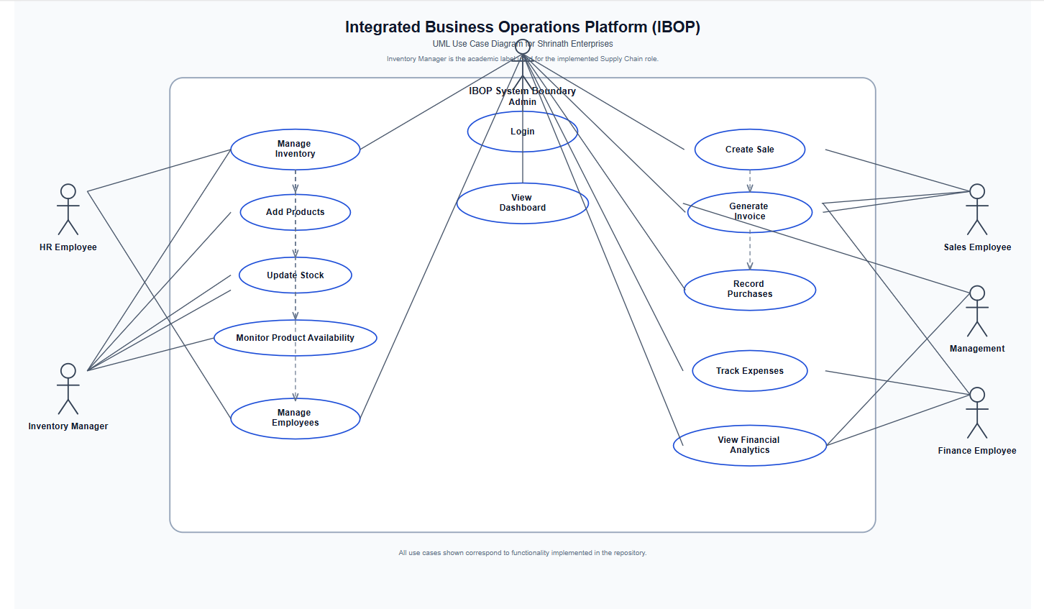
Figure 3.3 Use Case Diagram

Authentication Module
The authentication module is responsible for secure user login, credential verification, session management, and role-based access control. The module validates employee credentials using JWT-based authentication and restricts system access based on predefined organizational roles.
Protected routes and middleware mechanisms ensure that only authorized users can access sensitive operational functionalities. The authentication system supports roles such as Admin, Sales Employee, HR Employee, Finance Employee, Management, and Inventory Manager.

Inventory Management Module
The inventory management module handles product-related operations and stock management within the system. The module allows users to add products, update stock quantities, maintain pricing information, and manage batch numbers and expiry dates.
Inventory synchronization is automatically performed during sales and purchase operations. When products are sold, stock quantities are reduced, while purchase operations update inventory quantities accordingly. The module also supports inventory tracking and operational visibility through dashboard integration.

Sales Management Module
The sales management module is responsible for recording and managing sales transactions within the organization. Users can create sales entries, select products, calculate pricing information, apply discounts, and generate final transaction records.
The module performs automatic calculations for GST, total amount, discount values, and final payable amount. During transaction processing, inventory quantities are validated and updated automatically to maintain stock consistency.
Sales records are also linked with invoice generation workflows and operational analytics modules.

Purchase Management Module
The purchase management module manages supplier purchases and inventory restocking operations. Users can record purchase entries, maintain supplier information, track purchase quantities, and update inventory stock levels.
When purchase records are created, the module checks whether the product already exists in the inventory system. Existing products are updated with revised stock quantities and pricing details, while new products are automatically added to the inventory database if required.
The purchase workflow is also integrated with expense management operations for maintaining financial synchronization.

Invoice Generation Module
The invoice generation module is responsible for creating invoice records from completed sales transactions. The module processes sales information, applies GST calculations, and generates invoice data for operational reporting and billing purposes.
The system supports PDF invoice generation for downloadable billing records. Invoice details include company information, product information, quantity, pricing, discount values, GST calculations, payment status, and due dates.
The invoice management workflow improves operational automation and simplifies billing processes within the organization.

Finance and Expense Management Module
The finance module manages organizational expense tracking and financial monitoring functionalities. Users can record manual expenses, categorize financial transactions, and monitor financial activities through dashboard analytics.
The module is integrated with purchase workflows, allowing automatic expense creation during inventory purchase operations. Financial data collected from expenses and operational transactions is used for reporting and analytical visualization.

Employee Management Module
The employee management module handles staff-related operations including employee registration, employee information management, role assignment, and organizational access control.
Employee roles are used by the authentication system to implement Role-Based Access Control (RBAC) across different operational modules. The module also supports employee listing, modification, and deletion functionalities.

Dashboard and Analytics Module
The dashboard module provides centralized operational visualization and reporting functionalities. It displays business insights related to inventory status, sales performance, financial activities, expenses, and operational summaries using graphical charts and analytical components.
The analytics system improves decision-making capabilities by providing real-time operational visibility and business monitoring features within a centralized interface.
The modular architecture of IBOP improves workflow organization and enables efficient communication between different operational components. By separating functionalities into independent modules, the system maintains scalability, flexibility, and maintainability while supporting centralized business management operations within a real-world organizational environment.

3.5 Authentication and Security Mechanisms
The Integrated Business Operations Platform (IBOP) implements secure authentication and authorization mechanisms to protect operational data and restrict unauthorized access to sensitive business functionalities. Since the platform manages organizational information related to inventory records, financial transactions, employee details, invoices, and operational workflows, maintaining system security and controlled accessibility is an important aspect of the proposed architecture.
The system uses JSON Web Token (JWT) based authentication for validating users and securing protected routes. JWT provides a stateless authentication mechanism where authenticated users receive signed tokens after successful login. These tokens are used for verifying user identity during subsequent API requests without maintaining server-side session storage.
The authentication workflow begins when a user submits login credentials through the frontend login interface. The credentials are transmitted securely to the backend authentication API, where the system validates the employee email and password against records stored in the MongoDB database. Upon successful credential verification, the backend generates a JWT token containing encoded user information and role details.
The generated token is returned to the frontend and used for accessing protected operational modules. During API requests, authentication middleware validates the token and verifies whether the requesting user is authorized to access the requested resource.

The authentication and authorization workflow implemented within the system is illustrated in Figure 3.4.
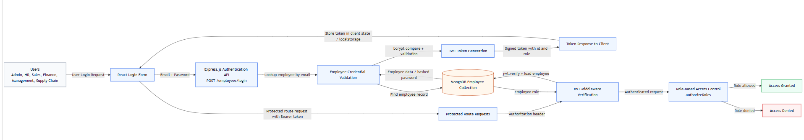
Figure 3.4 Authentication Workflow Diagram

JWT-Based Authentication
JWT authentication is implemented to provide secure and scalable access management across the platform. The authentication mechanism performs the following operations:
- User credential verification
- JWT token generation
- Protected API access validation
- Stateless session management
- Secure route protection
The token-based authentication approach improves scalability and simplifies secure communication between frontend and backend components within the MERN stack architecture.

Role-Based Access Control (RBAC)
The system implements Role-Based Access Control (RBAC) to restrict operational functionalities according to organizational roles and responsibilities. Each employee record contains role information used for access validation during authentication and API processing.
The primary roles implemented within the system include:
- Admin
- Sales Employee
- HR Employee
- Finance Employee
- Management
- Inventory Manager
Different roles are granted access only to functionalities relevant to their operational responsibilities. For example, sales employees can manage sales transactions and invoice generation, while finance employees can access expense management and financial analytics modules.
The RBAC architecture improves operational security and prevents unauthorized modification of sensitive organizational data.

Protected Routes and Middleware
Authentication middleware is integrated within the backend architecture to secure protected routes and validate incoming API requests. Middleware functions intercept requests before controller execution and verify the authenticity of JWT tokens.
If token verification fails or the requesting user lacks sufficient authorization privileges, the system denies access and returns appropriate error responses. This mechanism prevents unauthorized access to restricted operational modules.
Protected routes are implemented for modules such as:
- Employee management
- Financial records
- Expense management
- Inventory modification
- Invoice management
- Dashboard analytics
Middleware-based security improves centralized access management and simplifies authorization handling across different operational modules.

Password Security
Employee passwords are securely stored using hashing mechanisms to prevent direct password exposure within the database. Password validation is performed during login authentication without storing plaintext credentials.
The implementation of secure password storage improves protection against credential compromise and unauthorized database access.

Operational Security Benefits
The authentication and security architecture implemented in IBOP provides several important operational advantages:
- Secure user authentication
- Controlled module accessibility
- Centralized authorization management
- Protected operational workflows
- Reduced unauthorized system access
- Improved user accountability
- Secure API communication
- Scalable authentication architecture
By integrating JWT authentication, RBAC mechanisms, middleware validation, and protected operational workflows, the proposed system maintains secure and structured access management suitable for real-world organizational deployment environments.

3.6 Workflow Design and Data Flow
The Integrated Business Operations Platform (IBOP) is designed to support synchronized operational workflows between different organizational modules such as inventory management, sales processing, purchase handling, finance tracking, employee management, and invoice generation. The workflow architecture enables smooth communication between frontend interfaces, backend APIs, database operations, and reporting modules within a centralized business management environment.
The system follows a structured operational flow where users interact with frontend modules developed using React.js, while backend APIs developed using Express.js process requests, validate operational logic, and communicate with the MongoDB Atlas database. Different workflows within the platform are interconnected to ensure consistency of operational data and real-time synchronization between modules.
The overall operational workflow and data movement within the system are illustrated in Figure 3.5.
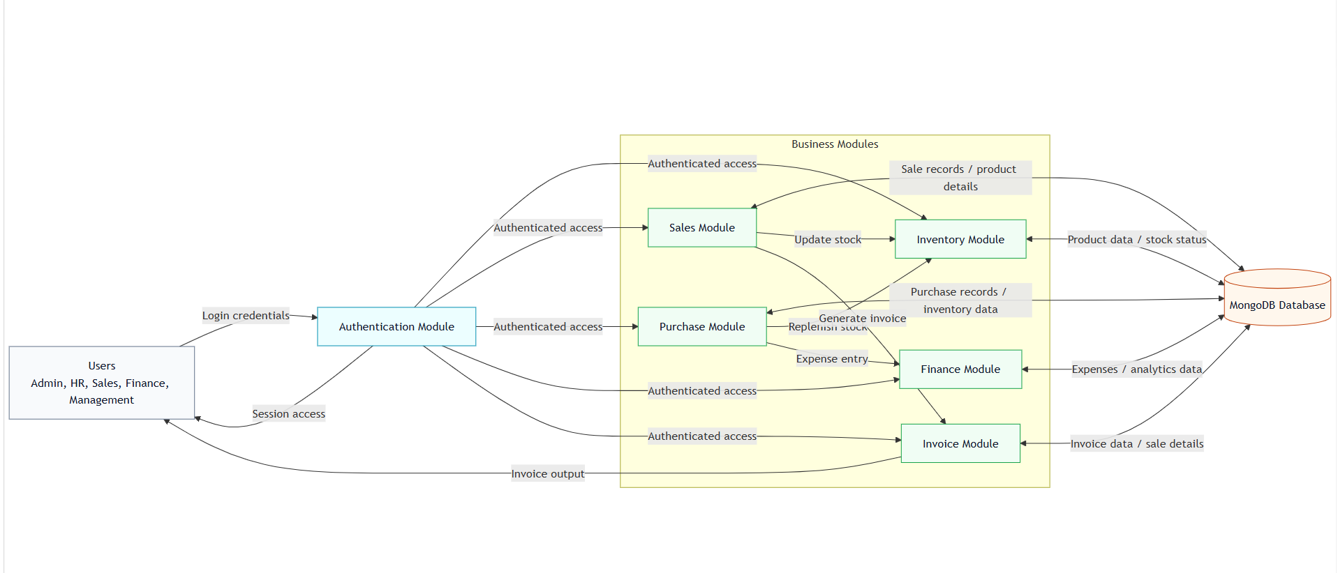
Figure 3.5 Operational Workflow Diagram

User Authentication Workflow
The workflow begins with user authentication through the login interface. Employees submit login credentials which are validated by the backend authentication API. After successful verification, the system generates JWT tokens and grants access to authorized modules based on user roles and responsibilities.
The authentication workflow ensures secure access management and controlled operational interaction within the system.

Inventory Workflow
The inventory workflow manages product storage, stock tracking, batch management, and inventory synchronization. Products can be added or updated through the inventory module, and inventory quantities are automatically modified during sales and purchase transactions.
When products are sold, stock quantities are reduced automatically. Similarly, purchase operations update stock quantities and maintain product availability records within the database.
The workflow improves inventory consistency and reduces manual stock management effort.

Sales and Invoice Workflow
The sales workflow handles sales transaction processing and billing operations. During sales creation, the system validates product availability, calculates pricing information, applies GST and discount calculations, and records the transaction in the database.
After successful sales processing, invoice records are automatically generated through the invoice module. The invoice generation workflow produces structured invoice data and supports PDF invoice generation for operational reporting and billing purposes.
The integration between sales and invoice modules improves workflow automation and operational efficiency.

Purchase and Expense Workflow
The purchase workflow manages supplier purchases and inventory restocking activities. When purchase entries are created, inventory quantities are updated automatically within the product database.
Simultaneously, the system creates corresponding expense records within the finance module to maintain synchronization between operational purchases and financial expenditure tracking.
This integrated workflow simplifies financial monitoring and improves coordination between procurement and finance operations.

Employee and Role Management Workflow
The employee management workflow handles employee registration, role assignment, and operational access management. Employee roles are used by the RBAC system to determine module accessibility and operational permissions within the platform.
The workflow supports controlled access management and improves organizational security through centralized role administration.

Dashboard and Analytics Workflow
Operational data from inventory, sales, purchases, invoices, and expenses is collected and processed by the analytics module for dashboard visualization and reporting purposes. The dashboard workflow provides graphical insights related to stock status, financial activities, sales performance, and organizational operations.
This workflow improves operational visibility and supports business decision-making through centralized analytical monitoring.
The workflow-oriented architecture of IBOP enables efficient communication between different operational modules while maintaining synchronized business records and centralized data management. The integration of authentication, inventory, sales, finance, and reporting workflows within a single platform improves organizational coordination, reduces manual operational effort, and enhances overall business management efficiency.

3.7 Advantages of Proposed System
The Integrated Business Operations Platform (IBOP) provides a centralized and scalable solution for managing multiple organizational workflows within a unified web-based environment. The proposed system integrates inventory management, sales handling, purchase tracking, invoice generation, employee management, financial monitoring, and dashboard analytics into a single operational platform. The modular architecture and workflow-oriented design provide several advantages over traditional fragmented management systems.

Centralized Operational Management
The system integrates multiple business operations into a unified platform, reducing dependency on disconnected software systems and manual record management. Centralized data storage and workflow integration improve coordination between different organizational departments and operational modules.

Improved Workflow Synchronization
IBOP automatically synchronizes operational activities between inventory, sales, purchases, invoices, and finance modules. Inventory quantities are updated automatically during sales and purchase transactions, while purchase workflows generate corresponding expense records within the finance module. This synchronization reduces data inconsistency and minimizes manual operational effort.

Secure Authentication and Access Control
The implementation of JWT-based authentication and Role-Based Access Control (RBAC) mechanisms improves operational security and controlled accessibility. Different users are granted access only to functionalities relevant to their organizational roles, reducing unauthorized access to sensitive operational data.

Scalable Modular Architecture
The modular layered architecture of the system improves maintainability and scalability of the application. Separate frontend interfaces, backend APIs, middleware components, and database models simplify system enhancement and support future feature expansion without affecting existing workflows.

Real-Time Inventory and Sales Management
The platform enables real-time monitoring of inventory quantities, sales transactions, and operational activities. Automatic stock synchronization and transaction validation improve inventory accuracy and operational reliability within the organization.

Automated Invoice Generation
The system automates invoice generation workflows and supports PDF invoice creation for billing and reporting purposes. Automated GST calculations, discount handling, and invoice processing reduce manual workload and improve operational efficiency.

Cloud-Based Data Management
The use of MongoDB Atlas provides centralized cloud-based data storage and improves accessibility, scalability, and operational reliability. Cloud database integration supports secure and organized management of business records and operational information.

Dashboard Analytics and Reporting
The analytics module provides graphical dashboard visualization and operational reporting functionalities. Business insights related to inventory status, financial activities, sales performance, and expense tracking improve decision-making capabilities and organizational monitoring.

User-Friendly Web Interface
The React.js-based frontend provides responsive and user-friendly interfaces for operational management. The platform simplifies navigation between modules and improves usability for organizational employees and administrators.

Industrial Relevance and Practical Implementation
The proposed system was developed as an external industry-oriented project based on operational requirements observed at Shrinath Enterprises. This practical implementation approach improves the real-world applicability of the platform and ensures that the system addresses actual business workflow challenges rather than purely theoretical scenarios.
The proposed architecture, workflow integration mechanisms, and centralized operational management capabilities make IBOP a practical and scalable solution for small and medium-sized enterprises seeking improved workflow coordination, secure access management, and efficient business operation handling within a modern digital environment

Chapter 4

Implementation and Experimental Results
This chapter presents the implementation details and operational workflows of the Integrated Business Operations Platform (IBOP). It explains the frontend and backend implementation, inventory and sales processing workflows, invoice generation mechanisms, financial management operations, role-based access control implementation, and system testing procedures. The chapter also demonstrates the practical execution of the proposed system through module-wise implementation details, workflow integration, backend processing, and user interface screenshots. Various operational diagrams and interface representations are included to illustrate the real-time functioning and workflow synchronization of the proposed platform.

4.1 Frontend Implementation
The frontend of the Integrated Business Operations Platform (IBOP) is developed using React.js to provide a responsive, modular, and interactive user interface for managing organizational workflows. The frontend architecture is designed to support seamless navigation between operational modules while maintaining scalability, component reusability, and efficient communication with backend APIs.
The frontend layer acts as the primary interaction point between users and the system. Employees and administrators access different functionalities such as inventory management, sales handling, purchase tracking, invoice generation, employee management, financial monitoring, and dashboard analytics through browser-based interfaces developed using React.js components.
The frontend implementation follows a component-based architecture where different functionalities are separated into reusable UI components and module-specific pages. This modular approach simplifies frontend maintenance and improves scalability for future feature expansion.

User Interface Design
The user interface is designed with a focus on usability, operational simplicity, and responsive layout management. Tailwind CSS is used for frontend styling and interface consistency across different modules of the application. The responsive design allows the platform to adapt to different screen sizes and improve accessibility across desktop environments.
The frontend includes multiple operational pages and dashboards designed for different organizational workflows.
Navigation between modules is handled through React Router, enabling smooth page transitions and protected route handling for authenticated users.
The implemented frontend interfaces include:
• Login Interface
• Dashboard Interface
• Inventory Management Page
• Sales Management Page
• Purchase Management Page
• Invoice Management Page
• Finance and Expense Tracking Page
• Employee Management Page
• Analytics and Reporting Dashboard
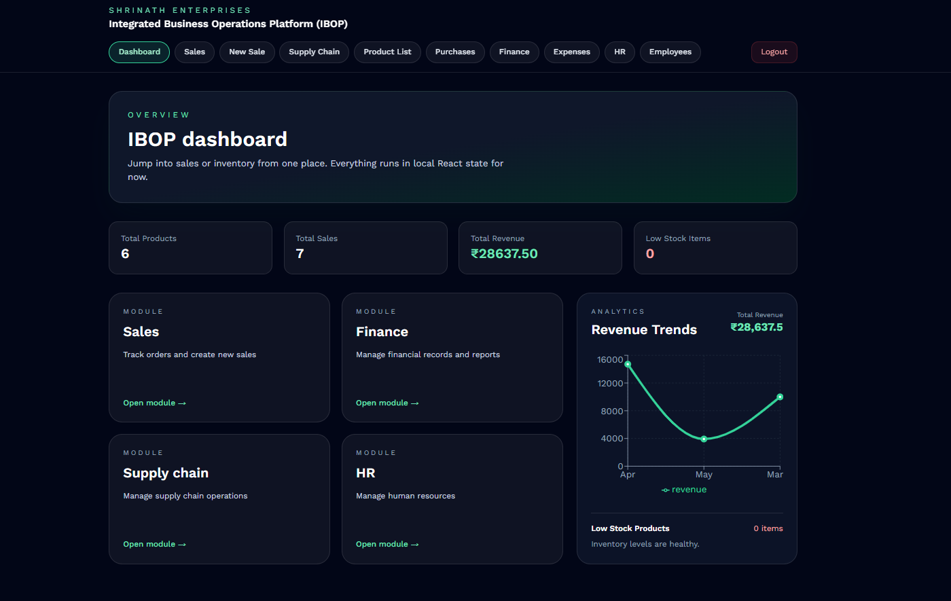
Figure 4.1 Dashboard Interface of IBOP

Dashboard Implementation
The dashboard module serves as the centralized operational overview of the system. It provides graphical and statistical visualization of organizational activities such as sales performance, inventory status, expense tracking, and financial summaries.
Charting and visualization libraries are integrated into the frontend to display operational analytics through graphical components. These visualizations improve operational monitoring and assist users in analyzing business performance efficiently.

Inventory and Product Management
The inventory workflow allows product addition, stock tracking, batch management, and product listing operations through dedicated frontend interfaces. Product information including pricing, stock quantity, batch number, and expiry date is managed dynamically through React-based forms integrated with backend APIs.
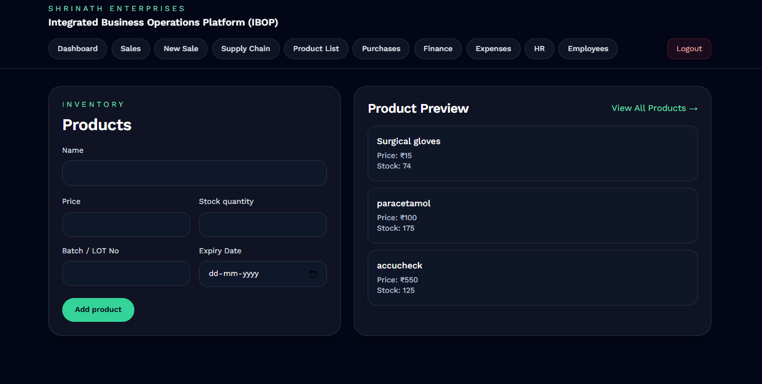
Figure 4.2 Product Addition and Inventory Management Interface
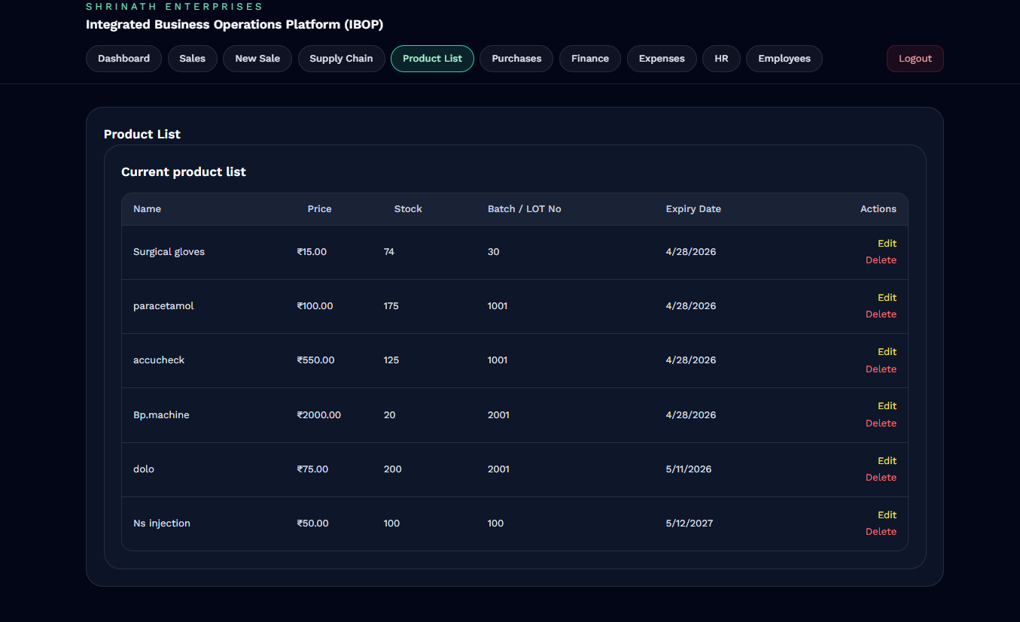
Figure 4.3 Product Inventory Listing Module

Sales Management Implementation
The sales module supports transaction management and operational record handling through interactive frontend interfaces. Users can view sales records, generate invoices, and monitor transaction details through dynamically rendered tables and forms.
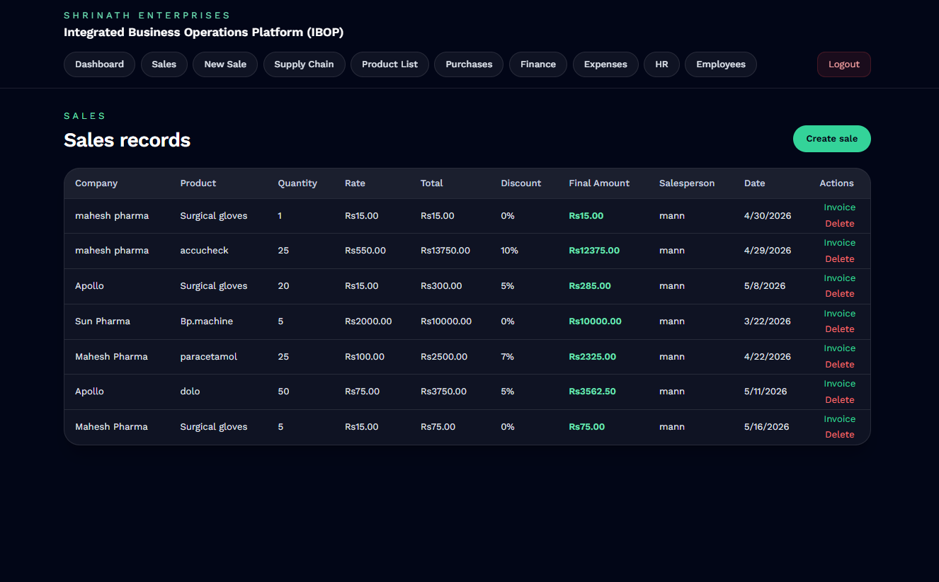
Figure 4.4 Sales Management and Transaction Records

The system supports creation of new sales transactions through dedicated billing interfaces integrated with inventory and invoice generation workflows.
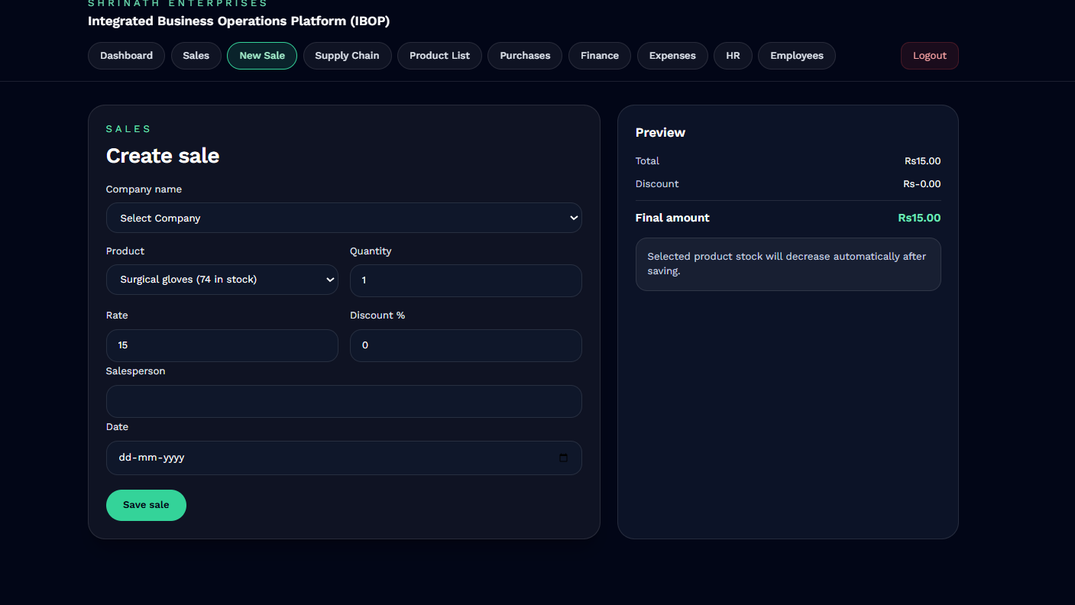
Figure 4.5 Sales Creation and Billing Workflow

Invoice Management
The system supports automated invoice generation and downloadable billing reports through integrated frontend and backend workflows. Invoice records are dynamically displayed and linked with PDF generation functionality.
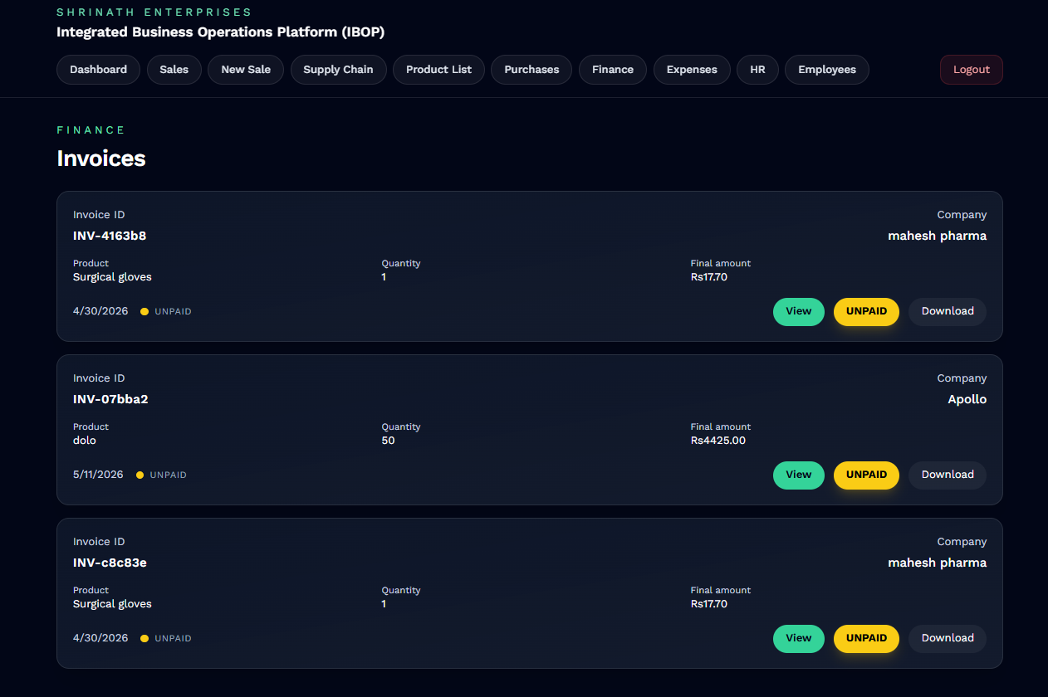
Figure 4.6 Invoice Management Module

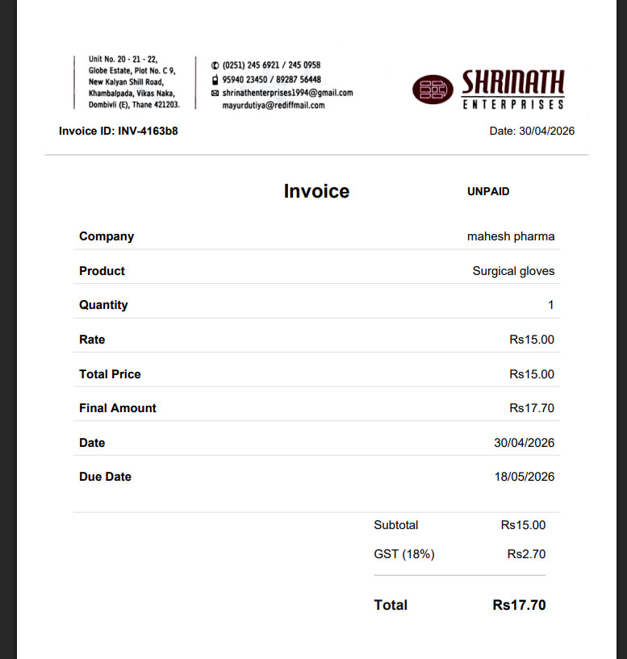
Figure 4.7 Generated PDF Invoice Document

Finance and Expense Tracking
The finance module supports expense tracking, financial analytics, procurement monitoring, and revenue visualization through dashboard-based graphical interfaces.
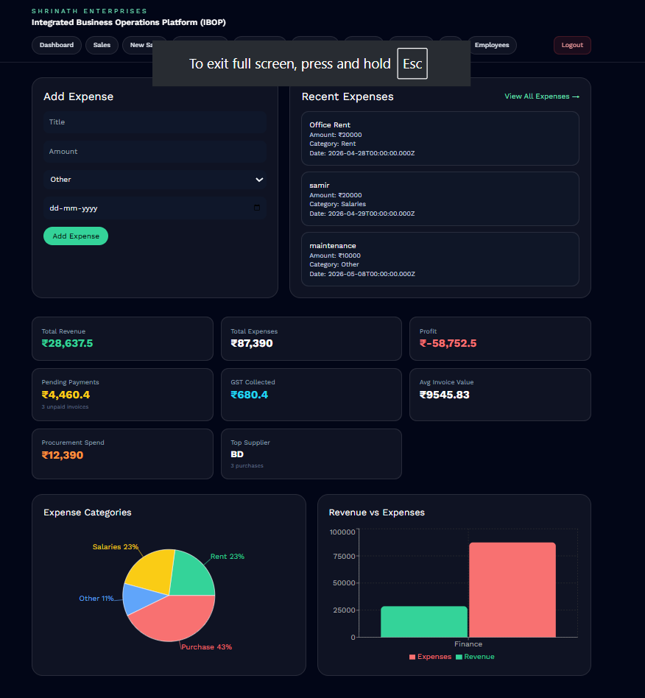
Figure 4.8 Financial Analytics and Expense Monitoring Dashboard
Expense records can also be managed dynamically using dedicated expense tracking interfaces integrated with backend financial workflows.
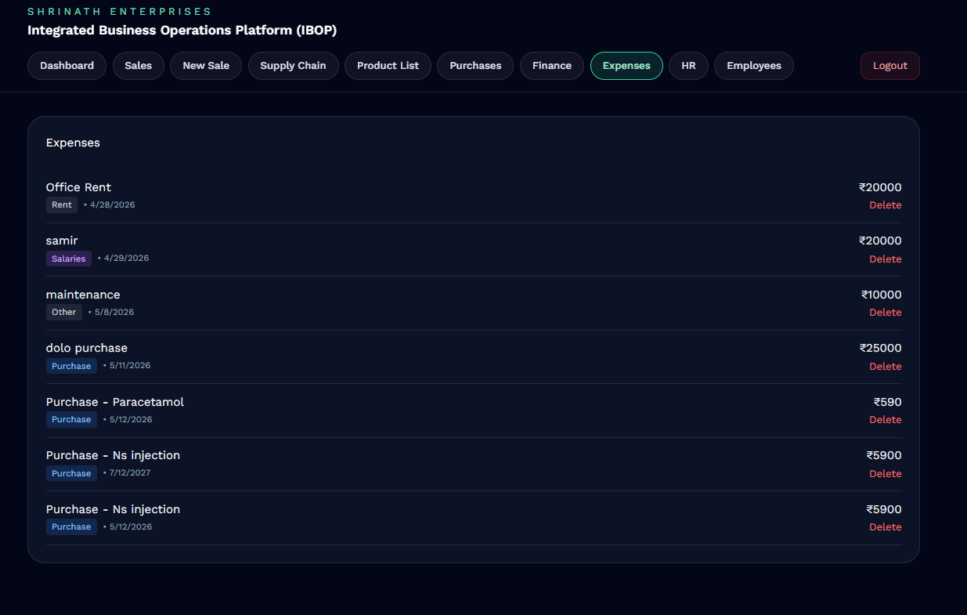
Figure 4.9 Expense Management Module

API Integration
The frontend communicates with the backend using RESTful API requests. Axios and fetch-based API communication mechanisms are used to transmit operational data between frontend interfaces and backend services.
Frontend forms are connected with backend APIs for handling operations such as:
• User authentication
• Product management
• Sales creation
• Purchase recording
• Invoice generation
• Expense management
• Employee operations
API responses are processed dynamically within React components to update frontend states and maintain real-time operational synchronization.

Protected Routes and Authentication Handling
Frontend authentication handling is implemented using JWT token management and protected route mechanisms. After successful login, JWT tokens are stored securely and attached to authorized API requests for validating protected backend routes.
Protected frontend routes restrict unauthorized users from accessing operational modules without valid authentication credentials. Role-based navigation handling is also implemented to provide module accessibility according to employee roles and responsibilities.

Employee Management Module
The employee management module handles organizational staff operations including employee registration, role allocation, department management, and employee record handling.
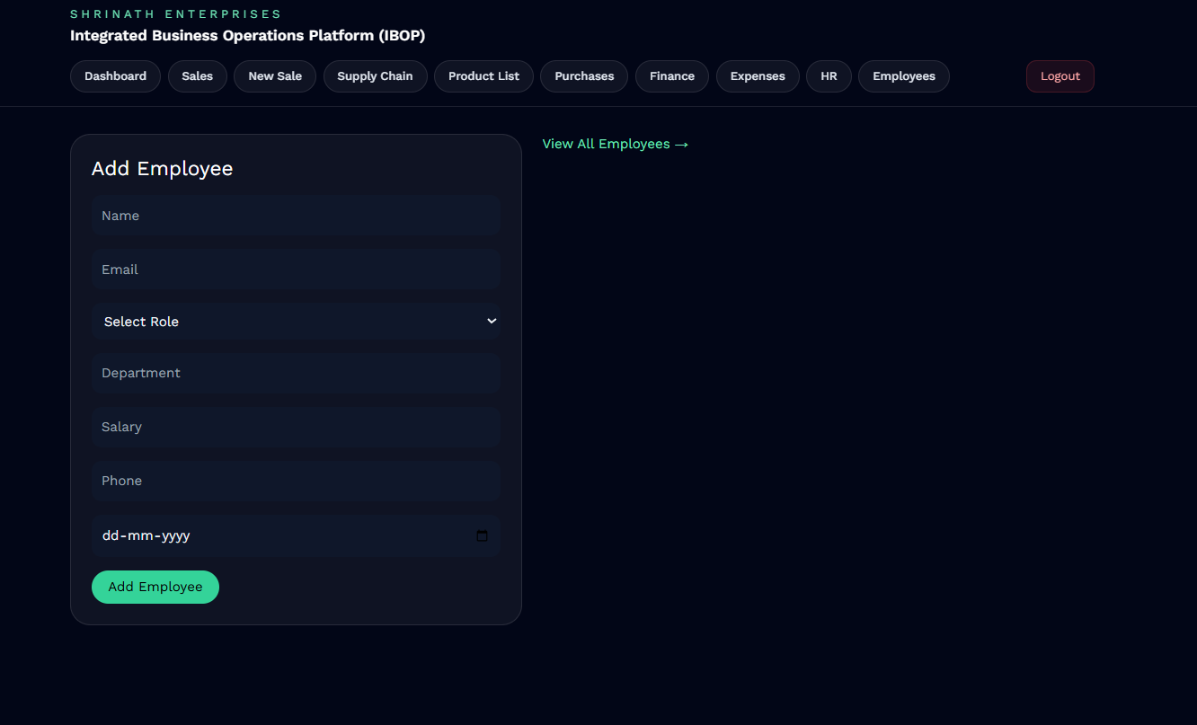
Figure 4.10 Employee Registration Interface
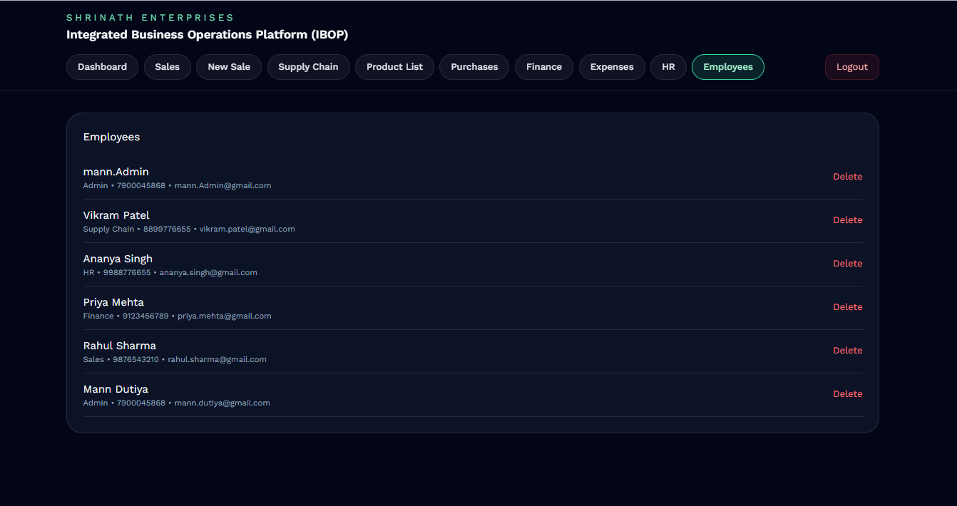
Figure 4.11 Employee Management and Role Administration

Form Handling and Validation
The frontend implementation includes dynamic forms for handling operational workflows such as product entry, sales creation, invoice processing, and employee management. Form validation mechanisms are implemented to reduce invalid data entry and improve operational accuracy.
Validation checks are performed for fields such as:
• product quantities
• pricing information
• employee details
• invoice calculations
• authentication credentials
This improves data consistency and enhances user interaction reliability.

Frontend Workflow Integration
The frontend modules are integrated with backend operational workflows to support real-time synchronization between inventory, sales, purchases, invoices, and financial operations. User actions performed through frontend interfaces trigger backend processing and database updates through API communication.
This integration enables smooth operational coordination and improves centralized workflow management within the system.
The frontend implementation provides a responsive and scalable operational interface suitable for centralized business management environments. By combining React.js component architecture, secure authentication handling, dynamic API communication, and modular UI organization, the frontend layer contributes significantly toward usability, workflow accessibility, and efficient operational management within the proposed platform.

4.2 Backend Implementation
The backend of the Integrated Business Operations Platform (IBOP) is developed using Node.js and Express.js to provide scalable server-side processing, API management, authentication handling, and database communication. The backend architecture is responsible for processing operational requests, validating business logic, managing workflows, and maintaining communication between frontend interfaces and the MongoDB database.
The backend follows a modular architecture where controllers, routes, middleware, and database models are organized separately to improve maintainability, scalability, and code readability. The backend implementation handles operational processes such as inventory management, sales processing, purchase tracking, invoice generation, employee management, expense monitoring, and financial analytics.
The server-side architecture is structured into multiple modules including:
• Configuration Layer
• Route Management Layer
• Controller Layer
• Middleware Layer
• Database Models
• API Services
• Authentication and Security Handling

Backend Project Structure
The backend implementation is organized into separate directories for routes, controllers, models, middleware, and configuration files. This modular organization simplifies debugging, scalability, and feature expansion.
The major backend folders include:
• config/ – Database configuration and environment setup
• controllers/ – Business logic implementation
• middleware/ – Authentication and authorization handling
• models/ – MongoDB schema definitions
• routes/ – API route definitions
• server.js – Main server initialization and middleware integration
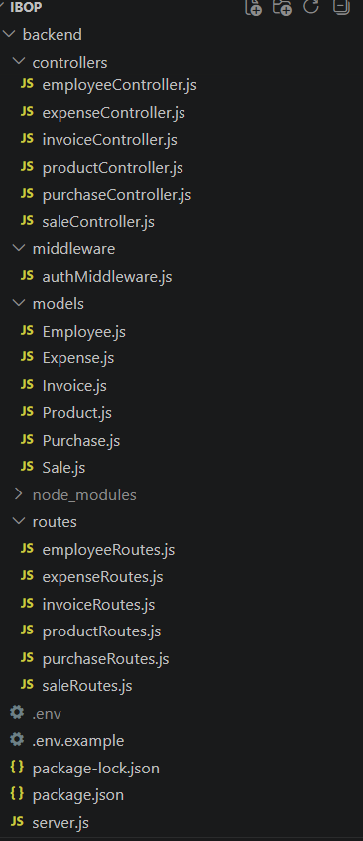
Figure 4.12 Backend Directory Structure of IBOP

Express Server Implementation
The backend server is implemented using Express.js. The server handles API routing, middleware execution, request parsing, authentication verification, and database connectivity.
The Express server is responsible for:
• Handling incoming API requests
• Connecting frontend interfaces with backend logic
• Managing route execution
• Processing JSON data
• Enabling middleware-based authentication
• Supporting RESTful communication
Middleware such as CORS handling, JSON parsing, and authentication verification are integrated into the Express server configuration to improve API communication and security handling.

Database Connectivity
MongoDB is used as the primary database system for storing operational records related to products, sales, purchases, invoices, expenses, and employee management. Mongoose is integrated for object modeling and schema management within the Node.js environment.
The database configuration layer establishes secure connectivity between the backend server and MongoDB collections. Database schemas are implemented using Mongoose models for handling structured operational data.
The implemented database models include:
• Product Model
• Sales Model
• Purchase Model
• Invoice Model
• Expense Model
• Employee Model

Controller Layer Implementation
The controller layer contains the core business logic responsible for processing operational workflows and handling API requests. Each operational module has a dedicated controller for managing CRUD operations and business processes.

The implemented controllers include:
• productController.js
• saleController.js
• purchaseController.js
• invoiceController.js
• expenseController.js
• employeeController.js
These controllers handle operations such as:
• Adding and updating inventory
• Processing sales transactions
• Recording purchases
• Generating invoices
• Tracking expenses
• Managing employee records

Route Management System
The route layer defines RESTful API endpoints used for communication between frontend modules and backend services. Each operational module contains separate route files connected with corresponding controllers.
The implemented route modules include:
• productRoutes.js
• saleRoutes.js
• purchaseRoutes.js
• invoiceRoutes.js
• expenseRoutes.js
• employeeRoutes.js
The routing architecture improves modularity and enables easier maintenance of operational APIs.

Authentication and Authorization
Authentication handling is implemented using JWT (JSON Web Token) mechanisms and middleware-based authorization verification. Protected routes restrict unauthorized users from accessing sensitive operational modules.
The authentication middleware validates user credentials and verifies secure token-based access for protected backend services.
The authentication system provides:
• Secure login validation
• Token generation and verification
• Protected API route handling
• Session-based operational security
• Role-based authorization support
As shown in Figure 4.13 Authentication Middleware Workflow

API Communication Workflow
The backend communicates with the frontend through RESTful APIs. Frontend modules send HTTP requests which are processed by Express routes and controllers before interacting with the MongoDB database.
The API communication workflow follows these steps:
- Frontend sends API request
- Express route receives request
- Controller processes business logic
- Database operation is performed
- Response is returned to frontend
This workflow ensures efficient synchronization between frontend interfaces and backend operational processing.
As shown in Figure 4.14 Backend API Workflow

Invoice Generation and File Handling
The backend includes invoice generation functionality for creating downloadable PDF invoices dynamically. Invoice data is processed through backend services and formatted into printable documents for operational use.
The invoice module supports:
• Invoice ID generation
• GST calculation
• Financial summary generation
• PDF invoice creation
• Downloadable invoice handling
The generated invoices are integrated with frontend invoice management interfaces for seamless financial workflow processing.

Backend Security and Validation
Input validation and operational security mechanisms are implemented throughout backend APIs to improve data integrity and reduce invalid operations.
Validation checks include:
• Required field validation
• Numeric and pricing validation
• Inventory quantity verification
• Authentication token verification
• API access restriction
Middleware-based validation improves operational reliability and reduces unauthorized access attempts.

Backend Workflow Integration
The backend implementation integrates multiple operational modules into a centralized workflow management system. Inventory, sales, purchases, invoices, expenses, and employee operations are interconnected through backend processing logic and database synchronization.
This integration enables:
• Automated inventory updates after sales
• Financial synchronization with purchases and expenses
• Dynamic invoice generation
• Real-time operational data handling
• Centralized workflow coordination
The backend implementation provides a scalable and secure server-side architecture for centralized business operation management. By combining Node.js, Express.js, MongoDB, JWT authentication, RESTful API handling, and modular workflow organization, the backend layer ensures efficient processing, operational synchronization, and secure management of organizational workflows within the IBOP system.

4.3 Inventory and Sales Workflow
The Integrated Business Operations Platform (IBOP) implements a synchronized inventory and sales workflow designed to automate stock management, transaction processing, and operational record handling within a centralized business environment. The workflow integrates frontend interfaces, backend APIs, database operations, and invoice generation mechanisms to ensure smooth coordination between inventory management and sales processing activities.
The inventory and sales modules are interconnected to maintain real-time stock synchronization and accurate transaction management. Product availability is automatically validated during sales operations, while inventory quantities are updated dynamically after successful transaction processing.
The operational workflow improves efficiency by reducing manual stock handling and minimizing inconsistencies between inventory records and sales transactions.

Inventory Management Workflow
The inventory workflow manages product addition, stock tracking, pricing updates, batch management, and product availability monitoring. Products are added through the frontend inventory management interface and stored within the MongoDB database using backend API services.
The inventory module allows users to:
• Add new products
• Update stock quantities
• Modify pricing information
• Manage batch numbers
• Track expiry dates
• Monitor available inventory
As shown in Figure 4.15 Product Addition Interface

The product listing interface provides centralized visibility of inventory records including product names, stock quantities, pricing details, and expiry information.
As shown in Figure 4.16 Product Inventory Listing

Sales Processing Workflow
The sales workflow handles transaction processing, billing operations, inventory synchronization, and invoice generation. Users can create sales transactions through dedicated frontend forms connected with backend APIs and database services.
During sales processing, the system performs multiple automated operations including:
• Product validation
• Stock availability checking
• Quantity calculation
• GST calculation
• Discount processing
• Final amount generation
• Inventory quantity updates
• Invoice record generation
The sales module ensures that inventory quantities are automatically reduced after successful transaction completion, maintaining accurate stock records across the system.
As shown in Figure 4.17 Sales Transaction Interface
The system also maintains centralized records of completed sales transactions through dynamically updated operational tables.
As shown in Figure 4.18 Sales Records Management

Workflow Synchronization
The inventory and sales modules are interconnected through backend controllers and database operations. When a sales transaction is completed, the backend automatically updates inventory quantities and generates related invoice records.
The synchronization workflow follows these steps:
- User creates sales transaction
- Backend validates product availability
- Stock quantities are verified
- Transaction details are processed
- Inventory records are updated
- Invoice records are generated
- Updated data is reflected on frontend dashboards
This workflow improves operational consistency and reduces manual inventory tracking effort.
As shown in Figure 4.19 Inventory and Sales Workflow Diagram

Operational Advantages
The integrated inventory and sales workflow provides several operational benefits including:
• Real-time stock synchronization
• Reduced manual inventory management
• Automated transaction processing
• Improved billing accuracy
• Faster operational handling
• Centralized sales monitoring
• Improved inventory visibility
The implemented workflow architecture enables efficient coordination between inventory handling and sales operations while maintaining centralized operational records within the system. By integrating frontend interfaces, backend APIs, automated calculations, and database synchronization mechanisms, the proposed workflow improves operational efficiency and simplifies organizational transaction management within the IBOP platform.

4.4 Invoice and Financial Management
The Integrated Business Operations Platform (IBOP) implements an integrated invoice and financial management system to support billing operations, expense monitoring, financial tracking, and operational analytics within a centralized organizational environment. The finance-related modules are interconnected with inventory, sales, and purchase workflows to maintain synchronized financial records and improve operational transparency across different business activities.
The invoice generation system automates billing workflows by dynamically creating invoice records directly from completed sales transactions. Financial information generated through operational workflows is further utilized for expense tracking, analytics visualization, and organizational reporting.

Invoice Generation Workflow
The invoice module is responsible for generating and managing invoice records associated with completed sales transactions. After successful sales processing, the backend automatically creates invoice entries containing transaction details, pricing summaries, GST calculations, discount information, and payment-related records.
The invoice generation workflow performs the following operations:
• Sales data extraction
• GST calculation
• Discount processing
• Invoice ID generation
• Financial summary generation
• PDF invoice creation
Generated invoice records are stored within the database and displayed dynamically through the invoice management interface previously illustrated in Figure 4.6.
The platform also supports downloadable PDF invoice generation for billing and documentation purposes. The generated invoice document format previously shown in Figure 4.7 demonstrates the implementation of automated invoice creation and printable financial reporting within the system.

Financial Management Workflow
The finance module manages organizational expenses, operational expenditure tracking, and financial analytics. Financial records are integrated with purchase workflows and expense management operations to maintain centralized monitoring of business transactions.
The finance workflow supports:
• Expense recording
• Expense categorization
• Procurement expense tracking
• Financial analytics generation
• Revenue and expenditure monitoring
Expense records are dynamically stored and managed through the finance management interface previously illustrated in Figure 4.9.

Analytics and Reporting
The finance module also includes dashboard-based analytical visualization for monitoring operational and financial activities. Graphical representations are used to display revenue trends, expense distributions, operational summaries, and business statistics.
The analytical dashboard previously illustrated in Figure 4.8 demonstrates the implementation of financial monitoring and operational analytics within the platform. These visualizations improve business monitoring capabilities and assist organizational decision-making through centralized reporting mechanisms.

Workflow Integration
The invoice and financial management modules are integrated with inventory, sales, and purchase workflows to maintain synchronized financial operations throughout the system.
The workflow integration includes:
- Sales transactions generating invoice records
- Purchase operations contributing to expense records
- Financial data updating analytics dashboards
- Invoice data supporting billing operations
- Backend APIs synchronizing operational transactions
This workflow integration reduces manual bookkeeping effort and improves consistency between operational activities and financial management processes.
As shown in Figure 4.20 Invoice and Financial Workflow Diagram

Operational Benefits
The implemented invoice and financial management system provides several operational advantages including:
• Automated invoice generation
• Improved financial tracking
• Centralized expense management
• Faster billing operations
• Real-time financial monitoring
• Improved operational reporting
• Reduced manual calculation effort
The integration of invoice generation, expense tracking, analytics visualization, and workflow synchronization improves financial transparency and operational efficiency within the proposed system. By combining backend automation, frontend visualization, and centralized database management, the IBOP platform provides a scalable and efficient financial management solution suitable for real-world organizational environments.

4.5 Role-Based Access Implementation
The Integrated Business Operations Platform (IBOP) implements Role-Based Access Control (RBAC) mechanisms to provide secure and controlled accessibility across different operational modules. Since the platform manages sensitive organizational data related to inventory, financial records, employee information, invoices, and operational workflows, controlled access management is an important aspect of the system implementation.
The RBAC architecture ensures that users can only access functionalities relevant to their organizational responsibilities. Access permissions are assigned according to predefined employee roles stored within the database and validated through backend authentication middleware.
The system supports multiple organizational roles including:
• Admin
• Sales Employee
• HR Employee
• Finance Employee
• Management
• Inventory Manager
Each role is granted controlled access to specific operational modules and functionalities within the platform.

Authentication Workflow
The authentication system is implemented using JWT (JSON Web Token) based authentication mechanisms integrated with backend middleware and protected API routes.
The authentication workflow includes:
- User login through frontend interface
- Credential verification through backend APIs
- JWT token generation after successful authentication
- Token validation during protected API requests
- Role verification through middleware
- Access granted or denied based on authorization level
The JWT authentication workflow previously illustrated in Figure 3.4 demonstrates the secure access management architecture implemented within the system.

Protected Route Handling
Protected routes are implemented within both frontend and backend layers to restrict unauthorized access to sensitive operational modules. Authentication middleware validates JWT tokens before granting access to protected APIs and operational functionalities.
The protected route implementation ensures that unauthorized users cannot access modules such as:
• Employee Management
• Financial Records
• Expense Tracking
• Inventory Modification
• Invoice Management
• Administrative Operations
This improves operational security and prevents unauthorized modification of organizational data.

Role-Based Module Accessibility
Different operational modules are dynamically accessible according to authenticated user roles. The frontend navigation system and backend authorization middleware work together to restrict module visibility and operational permissions.
Examples of role-based functionality include:
• Sales Employees managing sales and invoices
• Finance Employees accessing expense analytics
• HR Employees managing employee records
• Inventory Managers handling stock operations
• Management accessing reports and analytics
• Admin having centralized system control
This modular accessibility structure improves organizational workflow separation and operational control.

Middleware-Based Authorization
Authorization validation is implemented using middleware integrated within backend API routes. The middleware intercepts incoming requests, validates authentication tokens, verifies user roles, and determines whether the requested operation is permitted.
The middleware architecture improves centralized authorization handling and simplifies security management across operational workflows.
As shown in Figure 4.21 Role-Based Authentication Workflow

Security Advantages
The RBAC implementation provides several operational and security-related advantages including:
• Controlled module accessibility
• Secure API protection
• Reduced unauthorized access
• Centralized user management
• Improved operational accountability
• Secure workflow handling
• Simplified permission management
The integration of JWT authentication, protected routes, middleware validation, and role-based authorization mechanisms improves overall system security and operational reliability. By implementing controlled accessibility and secure workflow management, the IBOP platform ensures protected handling of organizational data and operational processes within a centralized business environment.

4.6 Testing and Validation
Testing and validation of the Integrated Business Operations Platform (IBOP) were performed to ensure proper functionality, workflow synchronization, operational reliability, and secure execution of different modules within the system. The testing process focused on validating frontend interfaces, backend APIs, authentication mechanisms, database operations, and workflow integration between different organizational modules.
The implemented system was tested under different operational scenarios including inventory handling, sales processing, invoice generation, employee management, expense tracking, and role-based access validation.

Functional Testing
Functional testing was performed to verify whether individual modules were operating according to expected business requirements. Each operational workflow was tested independently to ensure correct data processing and system behavior.
The following modules were tested:
• User Authentication Module
• Inventory Management Module
• Sales Management Module
• Purchase Management Module
• Invoice Generation Module
• Expense Management Module
• Employee Management Module
• Dashboard and Analytics Module
The testing confirmed that all operational modules performed successfully and maintained proper workflow synchronization throughout the system.

API Testing
Backend APIs were tested to validate request handling, response generation, database connectivity, and operational processing. API endpoints were verified for correct CRUD functionality and secure communication between frontend and backend layers.
The API testing process included:
• GET request validation
• POST request validation
• PUT request validation
• DELETE request validation
• Authentication token verification
• Protected route testing
The testing confirmed proper communication between frontend interfaces and backend services.

Authentication and Security Testing
Authentication workflows and protected route mechanisms were tested to ensure secure accessibility and controlled operational management.
Security testing included:
• Login credential validation
• JWT token verification
• Protected route access testing
• Unauthorized access prevention
• Role-based accessibility validation
The testing confirmed that unauthorized users were restricted from accessing protected operational modules and sensitive organizational data.

Database Validation Testing
Database testing was performed to verify proper storage, retrieval, updating, and synchronization of operational records within MongoDB.
The database validation process included:
• Product record validation
• Sales transaction verification
• Invoice generation validation
• Expense record synchronization
• Employee data management
• Inventory quantity synchronization
The testing confirmed that backend workflows successfully maintained consistent and synchronized operational records throughout the platform.

User Interface Testing
Frontend interfaces were tested for responsiveness, usability, navigation handling, and operational accessibility. Different pages and modules were tested to ensure smooth interaction between frontend components and backend APIs.
The UI testing process verified:
• Responsive page rendering
• Form validation
• Dashboard accessibility
• Navigation handling
• Dynamic data rendering
• Workflow responsiveness
The frontend implementation demonstrated stable operational performance and smooth user interaction across different modules.

Workflow Integration Testing
Integration testing was performed to validate synchronization between inventory, sales, invoices, expenses, and financial workflows.

The workflow integration testing verified:
- Sales transactions updating inventory quantities
- Invoice generation after sales processing
- Purchase records affecting expense management
- Financial analytics updating dynamically
- Role-based workflows operating correctly
The testing confirmed successful coordination between interconnected operational modules.

Test Results
The implemented system successfully passed operational workflow testing and demonstrated stable performance during module interaction and transaction processing.
The testing process verified:
• Accurate inventory synchronization
• Proper invoice generation
• Successful financial tracking
• Secure authentication handling
• Stable API communication
• Reliable database operations
• Controlled role-based accessibility
The overall validation process confirmed that the proposed system operates efficiently and satisfies the intended business workflow requirements.
Table 4.1 System Testing Summary
Module | Testing Status | Result
Authentication Module | Tested | Successful
Inventory Management | Tested | Successful
Sales Workflow | Tested | Successful
Invoice Generation | Tested | Successful
Expense Management | Tested | Successful
Employee Management | Tested | Successful
Dashboard Analytics | Tested | Successful
API Communication | Tested | Successful
Database Synchronization | Tested | Successful

The testing and validation procedures demonstrate that the IBOP platform successfully integrates frontend interfaces, backend processing, database synchronization, authentication mechanisms, and workflow automation into a stable and operational business management solution suitable for real-world organizational environments.

4.7 Results and Discussion
The Integrated Business Operations Platform (IBOP) was successfully developed and implemented as a centralized business management solution for handling inventory management, sales processing, invoice generation, employee administration, expense tracking, and financial analytics within a unified web-based environment.
The implemented system demonstrated successful integration between frontend interfaces, backend APIs, authentication mechanisms, database synchronization, and workflow automation modules. The platform was capable of handling real-time operational workflows while maintaining secure and organized management of organizational data.

Operational Results
The proposed system successfully achieved the intended operational objectives identified during requirement analysis and workflow planning stages.
The implemented platform demonstrated:
• Centralized operational management
• Automated inventory synchronization
• Secure role-based accessibility
• Dynamic invoice generation
• Financial tracking and analytics
• Real-time database synchronization
• Responsive frontend interaction
• Modular backend processing
The integration of inventory, sales, finance, and employee management workflows reduced manual operational effort and improved workflow coordination across different business modules.

Frontend and User Experience Results
The React.js frontend implementation provided responsive and interactive interfaces for organizational workflow handling. Dynamic dashboards, operational forms, and analytics visualizations improved usability and simplified navigation between modules.
The implemented frontend successfully supported:
• Real-time operational updates
• Dashboard analytics visualization
• Dynamic data rendering
• Responsive page navigation
• Protected route accessibility
• Operational workflow interaction
The user interface demonstrated stable performance during operational testing and workflow execution.

Backend and Database Performance
The Node.js and Express.js backend architecture successfully handled API communication, authentication processing, workflow synchronization, and database interaction.
MongoDB integration enabled efficient storage and retrieval of operational records related to products, sales, invoices, expenses, and employee management.
The backend implementation demonstrated:
• Stable REST API communication
• Secure JWT authentication
• Efficient database synchronization
• Modular controller execution
• Workflow automation handling
• Real-time operational processing
The modular backend architecture also improved maintainability and future scalability of the system.

Workflow Automation Results
One of the major outcomes of the proposed system was successful workflow automation between interconnected business modules.
The implemented automation workflows included:
- Automatic inventory updates after sales transactions
- Invoice generation after sales processing
- Expense synchronization during purchase operations
- Dynamic financial analytics updates
- Role-based module accessibility handling
These automation mechanisms reduced manual record management and improved consistency between operational workflows.

Security and Access Control Results
The JWT-based authentication and Role-Based Access Control (RBAC) mechanisms successfully restricted unauthorized access to protected operational modules.
The implemented security system provided:
• Secure user authentication
• Protected route handling
• Controlled module accessibility
• Middleware-based authorization
• Operational access management
The authentication workflow maintained secure interaction between frontend interfaces, backend APIs, and database services.

Industrial Relevance
The project was developed as an external industry-oriented solution based on operational requirements observed at Shrinath Enterprises. The implementation focused on addressing practical business workflow challenges rather than purely theoretical functionality.
The proposed platform demonstrated how centralized digital systems can improve operational efficiency, workflow coordination, inventory tracking, financial monitoring, and organizational management within small and medium-scale business environments.

Overall Discussion
The implementation and testing results demonstrate that the proposed system successfully integrates multiple business workflows into a centralized and scalable web-based platform. The combination of React.js, Node.js, Express.js, MongoDB, JWT authentication, and modular workflow architecture enabled efficient operational management and secure handling of organizational data.
The system provides a practical foundation for future enhancements such as advanced analytics, cloud deployment optimization, mobile accessibility, automated reporting, and additional enterprise workflow integrations.
The overall implementation confirms that the Integrated Business Operations Platform (IBOP) is capable of improving workflow automation, operational transparency, financial monitoring, and centralized business management within real-world organizational environments.

Chapter 5

Conclusions and Further Scope
This chapter presents the conclusion and overall outcomes of the Integrated Business Operations Platform (IBOP). It summarizes the implementation, operational workflows, system performance, and major achievements of the proposed platform. The chapter also discusses the practical significance of the system, industrial applicability, future enhancement possibilities, and limitations of the current implementation. The overall discussion highlights how the proposed system improves workflow automation, operational coordination, financial management, and centralized business operations within organizational environments.

5.1 Conclusion
The Integrated Business Operations Platform (IBOP) was successfully designed and implemented as a centralized web-based business management system for handling inventory management, sales processing, invoice generation, employee administration, expense tracking, and financial monitoring within a unified operational environment.
The proposed system integrates multiple organizational workflows into a single platform using the MERN technology stack consisting of MongoDB, Express.js, React.js, and Node.js. The implementation focused on improving workflow coordination, operational transparency, inventory synchronization, secure access management, and automated financial processing within business operations.
The developed platform successfully achieved the primary objectives identified during the requirement analysis phase. The system demonstrated efficient frontend-backend integration, secure JWT-based authentication, role-based access control, real-time database synchronization, automated invoice generation, and centralized operational management.
The modular architecture implemented within the system improved maintainability, scalability, and workflow organization. The integration between inventory, sales, finance, and employee management modules reduced manual operational effort and improved consistency across organizational processes.
The project was developed as an external industry-oriented solution based on operational requirements observed at Shrinath Enterprises. This practical implementation approach ensured that the proposed system addressed real-world business workflow challenges rather than purely theoretical operational scenarios.
The implementation and testing results confirmed that the proposed platform operates efficiently and provides a scalable foundation for centralized business management within small and medium-scale organizational environments. The successful integration of operational workflows, financial management, authentication systems, and analytical dashboards demonstrates the effectiveness of the proposed architecture and implementation methodology.
The Integrated Business Operations Platform (IBOP) therefore represents a practical and scalable digital solution capable of improving operational efficiency, workflow automation, financial transparency, and centralized organizational management within real-world business environments.

5.2 Future Scope
Although the proposed system successfully implements centralized business workflow management, several enhancements and advanced features can be incorporated in future versions to further improve scalability, automation, and operational intelligence.
Possible future enhancements include:
• Cloud deployment and production-scale hosting
• Mobile application integration
• Advanced analytics and AI-based business forecasting
• Multi-branch organizational support
• Barcode and QR-code inventory integration
• Real-time notification systems
• Automated email and SMS invoice delivery
• Advanced report generation and export features
• Integration with payment gateways
• Enhanced cybersecurity and audit logging mechanisms
Future improvements can also focus on improving scalability for large enterprise environments and expanding support for additional organizational workflows.
The modular architecture of the proposed system allows future feature integration without major modification to the existing implementation. This flexibility provides a strong foundation for extending the platform into a more advanced enterprise resource management solution capable of supporting larger organizational ecosystems and more complex operational requirements.

APPENDIX A

API ENDPOINT TABLES
Backend API Endpoints

Authentication APIs
Method | Endpoint | Description
POST | /api/auth/login | User login authentication
POST | /api/auth/register | Employee registration
GET | /api/auth/profile | Fetch authenticated user profile

Product APIs
Method | Endpoint | Description
GET | /api/products | Retrieve all products
POST | /api/products | Add new product
PUT | /api/products/:id | Update product details
DELETE | /api/products/:id | Delete product
GET | /api/products/:id | Retrieve product by ID

Sales APIs
Method | Endpoint | Description
GET | /api/sales | Retrieve all sales records
POST | /api/sales | Create new sales transaction
GET | /api/sales/:id | Retrieve sales details
DELETE | /api/sales/:id | Delete sales record

Purchase APIs
Method | Endpoint | Description
GET | /api/purchases | Retrieve purchase records
POST | /api/purchases | Create purchase entry
DELETE | /api/purchases/:id | Delete purchase record

Invoice APIs
Method | Endpoint | Description
GET | /api/invoices | Retrieve invoices
POST | /api/invoices | Generate invoice
GET | /api/invoices/:id | Retrieve invoice details
DELETE | /api/invoices/:id | Delete invoice

Expense APIs
Method | Endpoint | Description
GET | /api/expenses | Retrieve expense records
POST | /api/expenses | Add expense
PUT | /api/expenses/:id | Update expense
DELETE | /api/expenses/:id | Delete expense

Employee APIs
Method | Endpoint | Description
GET | /api/employees | Retrieve employee records
POST | /api/employees | Add employee
PUT | /api/employees/:id | Update employee details
DELETE | /api/employees/:id | Delete employee

Dashboard & Analytics APIs
Method | Endpoint | Description
GET | /api/dashboard/stats | Retrieve dashboard analytics
GET | /api/analytics/finance | Retrieve financial analytics
GET | /api/analytics/sales | Retrieve sales analytics

APPENDIX B

Company Collaboration Letter
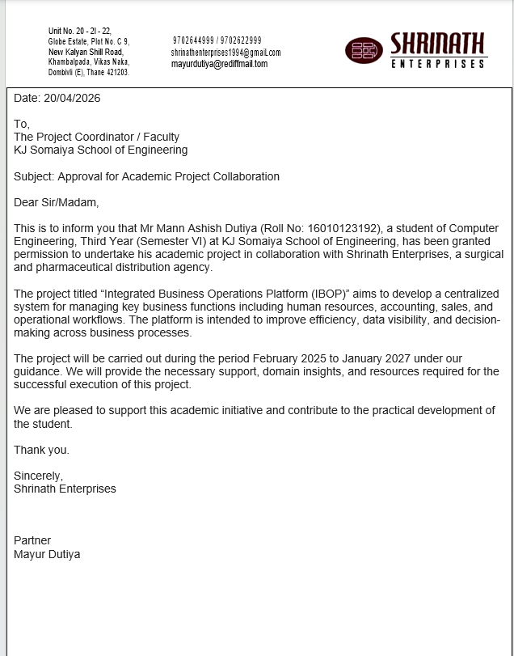

REFERENCES
[1] A literature review on ERP implementation: Methodologies, module, software, and policy Muhammad Faisal Ibrahim ; Yogantara Setya Dharmawan; Ngatini; M. Ilham Mustofa; Dana Marsetiya Utama
[2] Implementation of Odoo-Based ERP in The Case Study of Micro, Small and Medium Enterprises (MSME) “Woody Moody Jakarta” Syafitri Lutfia Zahra1 , Syaifudin2 , Teddy Siswanto3*
[3] ERP SYSTEMS ARCHITECTURE FOR THE MODERN AGE: A REVIEW OF THE STATE OF THE ART TECHNOLOGIES Mohammad Amini Valashani1,* , Arnold Mashud Abukari2
[4] ERP ODOO IMPLEMENTATION IN SMALL RETAILERS Ary Arvianto, Zainal Fanani Rosyada, Singgih Saptadi, Wiwik Budiawan and Yasa Ewa Demilda
[5] Modular Architecture in .NET Enterprise Systems: Patterns, Practices, and Evolution toward Scalable Systems Author: Hema Latha Boddupally
[6] React Documentation, Meta Platforms Inc. Available:
React Official Documentation
[7] Node.js Documentation, OpenJS Foundation. Available:
Node.js Official Documentation
[8] Express.js Documentation. Available:
Express.js Official Documentation
[9] MongoDB Atlas Documentation. Available:
MongoDB Official Documentation
[10] JWT Authentication Documentation. Available:
JWT Official Introduction
[11] Tailwind CSS Documentation. Available:
Tailwind CSS Official Documentation
[12] GitHub Documentation. Available:
GitHub Docs

